M.R VIVEKANANDA MODEL SCHOOL, Sector – 13 Dwarka
HOLIDAY HOMEWORK
CLASS – 9 (2019-20)
Dear parents,
The most awaited Summer Break is from 18^{h} May to 28th June. As per forecast by weather department the temperature will rise more and warm breeze (Loo) will blow. We suggest the following measures for your ward to remain healthy and hydrated:
- Wear cotton clothes, consume more liquids and water, go for morning walks. We want our students to utilize this time in a fruitful manner.
- Remain indoorfor most of the time, read newspapers, spend value time with elders and grandparents, help parents with daily chores, watch TV channels like National Geographic and Discovery.
Teachers have planned interesting, creative and knowledgeable home work.
Ensure that your ward does the Holiday Homework on his/her own using innovations. Guide and assist them only.

Principal
ENGLISH
1.Read the newspaper daily and write two new words daily in a Vocabulary Notebook and make sentences of the words.
2.Write twenty five idioms and their meanings in a Vocabulary Notebook.
3.Read chapters of book 1-Beehive Which were taught in the class.
4.Read chapters 1-10 of book 2-Moments .Write Summary and Keywords in a colourful Scrap book.
5.Write a poem using atleast three poetic devices(10-15 lines),based on nature, Friendship, Mother, grandparents,School in a A4 size coloured sheet.

SOCIAL SCIENCE
- Visit a heritage site in Delhi and prepare a report on your visit.
- Read one English newspaper daily.
- Prepare a Report on the result of Lok Sabha elections on A-4 sheets
- Revise the syllabus done in class till date.
- Make a chart on the economic activities of man.
- Prepare a model on the topic as per your roll no.
- River system- Ch-3 geography (roll nos.- 1-12)
- A model showing forest life (roll nos:13-23)
- Physical Features or relief (roll nos:24 onwards)
- Prepare a project file on disaster management(compulsory project)
DETAIL OF PROJECT: TOPIC NATURAL DISASTERS
- Title page -Project title ,Your name, Name of the School and Subject Teacher and class.
- Acknowledgement- It is usual to thank the individuals who have provided you assistance with the project.
- Content Page- A page-wise list of the Main sections and the sub- sections of your report.
- TEXT FOR YOUR PROJECT:
- Natural disasters – Introduction and meaning
- Types of disasters
- Floods
- Droughts
- Earthquakes
- Landslides
- Tsunamis
- Cloud burst
- Every topic should include pictures about disasters and its mitigation measures.
- Last page of the report should include:
Evaluation report
1. | Accuracy of content
2. | Creativity
3. | Teachers assessment

MATHEMATICS
Class 9
(1)Make one chart on any of the topic given below.
(2)Make a model according to the roll numbers
- Square root spiral (1-3)
- Represent √6.5 on the number line (4-6)
- Types of triangles (7-9)
- Types of angles (10-12)
- Algebraic identities (13-15)
- Angle sum property of a triangle (16-18)
- Special type of quadrilateral and their property(any one) (19-21)
- Angle subtended by equal chords (22-24)
- Equal chords are equidistant from the centre (25 -27)
- The angle subtended by an arc at the centre is double the angle subtended by it at any point on the remaining part of the circle .( 28-30)
- Surface area and volume (any one) (31-33)
- Frequency polygon (34-36)
- Probability( 37-39)
(3) Do practice of ch 1 , ch 2 , and ch 6 from NCERT.
(4) Do practice of 5 sums daily from reference book.

COMPUTER
Project: Make a project on following topics according to your Roll No.

Roll No. | Topics
1-5 | Make a chart on etiquettes
6-10 | Make a chart on Input Devices
11-15 | Make a model of Internet
16-20 | Make a chart of component of a computer system
21-25 | Make a chart on areas of application of Internet
26-30 | Make chart on memory unit
31-35 | Make a model on Input Devices
36 onwards | Make a chart or model on Characteristics of computer system
SCIENCE
Physics- Learn motion and do exercise in revision.
Chemistry- Learn matter in our surrounding and do exercise in revision.
Biology- Learn cell and Tissue chapters, complete your Practical files.
Prepare colourfull chart according to roll no.
S No. | Topic | Roll No.
1. | Electric free energy generator | 9thA 1 to5
2. | Water level Indicator | 6 to 10
3. | Bio diesel | 11 to 15
4. | Telescope | 16 to 20
5. | Periscope | 21 to 25
6. | Water rocket | 26 to 30
7. | Working Model of heart | 31 to 35
8. | Respiratory | 35 to onward
9 | D.N.A. Working Model | 9thB 1 to5
10. | Using E- waste | 6 to 10
11. | Dialysis | 11 to 15
12. | Excretory System | 16 to 20
13. | Biogas Plant | 21 to 25
14. | First Aid Box | 26 to 30
15. | AIDS Virus | 31 to 35
16. | Chikungunya | 35 to onward
17. | Ebola Virus | 9thC 1 to5
18. | Solar Detector | 6 to 10
19. | Nipah Virus | 11 to 15
20. | Water Filtration (By Ancient and modern method) | 16 to 20
21. | Cell structure | 21 to 25
22. | Periodic table | 26 to 30
23. | Heart Disease | 31 to 35
24. | Kidney Disease | 35 to onward

Prepare a scrap file on different airborne, waterborne, insect/worm diseases which prevail in your neighbourhood. (at least ten diseases with name, carriers causes, prevention.)
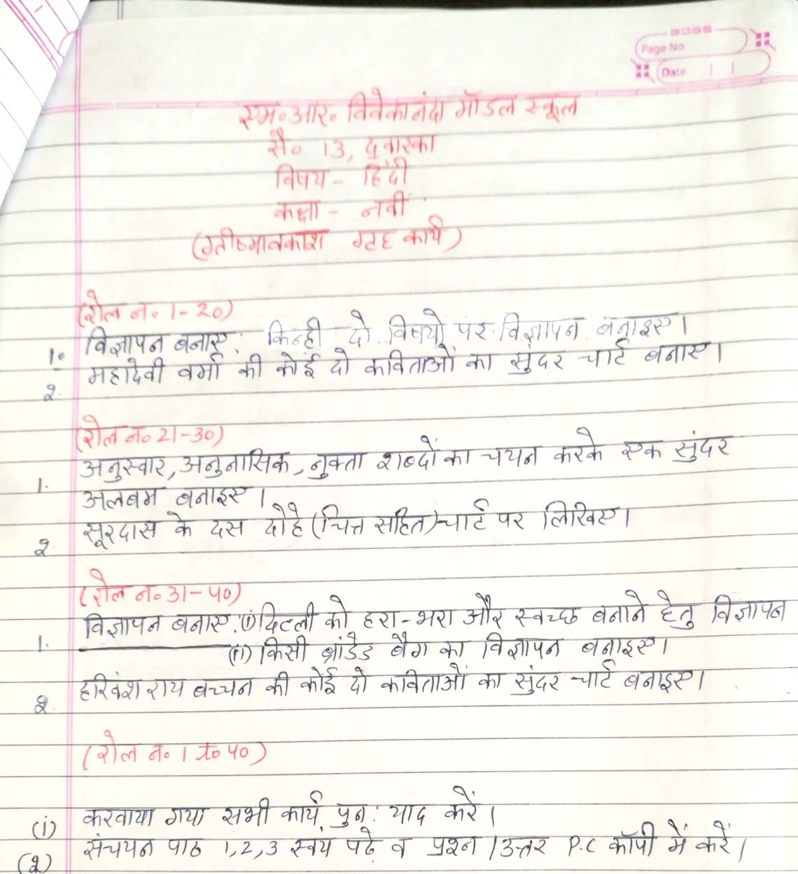
Our Expectations from Parents
Dear Parents,
Our school management and teachers try to instil soft values in our students in their daily routine
like caring and sharing , good relationships and mutual respect etc. We request all parents to reinforce such values in their wards during summer vacations and thereafter.
So please take care of the following:
1. Parents are requested to spend some quality time with their children .
2. Get some good storybooks with colourful pictures for your ward and tell your child to read them
regularly.
3. Let them sow some seeds / a plant and look after the plant regularly and watch them grow.
4. Let your ward spend minimum time in T.V , using mobile phones, internet and other electronic gadgets.
5. Encourage them to write two pages transcriptions daily to improve their handwriting .
6. Give stress on practicing one moral value daily.
7. Encourage your child to help you in small thingsrelated to Kitchen/Cleanliness.
8. Discourage your child to eat fast food like burger, pizza and carbonated drinks.
9. Allow your child to play outdoors games as it helps to make them strong.
10. Plan a holiday trip with your family for recreation.

Wishing you Happy and fruitful holidays.

Principal

