M.R VIVEKANANDA MODEL SCHOOL, Sector – 13 Dwarka
HOLIDAY HOMEWORK
CLASS – 10 (2019-20)
Dear parents,
The most awaited Summer Break is from 18^{h} May to 28th June. As per forecast by weather department the temperature will rise more and warm breeze (Loo) will blow. We suggest the following measures for your ward to remain healthy and hydrated:
- Wear cotton clothes, consume more liquids and water, go for morning walks. We want our students to utilize this time in a fruitful manner.
- Remain indoorfor most of the time, read newspapers, spend value time with elders and grandparents, help parents with daily chores, watch TV channels like National Geographic and Discovery.
Teachers have planned interesting, creative and knowledgeable home work.
Ensure that your ward does the Holiday Homework on his/her own using innovations. Guide and assist them only.

Principal
ENGLISH
1.Read the newspaper daily and write two new words daily in a Vocabulary Notebook and make sentences of the words.
2.Write thirty idioms and their meanings in a Vocabulary Notebook.
3.Read chapters of book 1-First Flight Which were taught in the class.
4.Read chapters 1-10 of book 2-Footprints without feet. Write Summary and Keywords in a colourful Scrap book.
5.Write a poem using atleast three poetic devices(10-15 lines),based on nature, Friendship, Mother, grandparents, School in a A4 size coloured sheet.

SOCIAL SCIENCE
- Students should read one English newspaper daily. Write a report on the Lok Sabha elections that are being declared and the 23rd of May. The report should be written on A-4 sheets.
- Revise the syllabus completed till date. Read the chapters as well.
- Prepare a project report in a file on any one of the topics given below (COMPULSORY PROJECT FOR CLASS 10).
- CONSUMER AWARENESS
OR
- SOCIAL ISSUES
OR
- SUSTAINABLE DEVELOPMENT
The highlights and details of the project will be discussed by the subject teacher in class.
Elements of the project:
- Title page -Project title, Name of the School and Subject Teacher and class.
- Acknowledgement- It is usual to thank the individuals who have provided you assistance with the project.
- Content Page- A page-wise list of the the Main sections and the sub- sections of your report.
- Introduction- This should be a clear summary of your project. It should begin with a statement of the basics of your project so that the reader has a clear understanding of the project.
- Detailed body of report- will be discussed by the teacher in class
- Central part of the report- should consist of three or four sections. (The structure, pictures and detailed textual description of the project)
- Evaluation and assessment by teacher(last page)- should consist of fourheadings
- S.NO. | - Description | - Grade
- i. | - Content Accuracy
- ii. | - Presentation and creativity
- iii. | - Process of completion and punctuality
- iv. | - Final Marks and grade

- Students also have to prepare a model (working or non- working) on the following topics-
- A dam or multipurpose project ( Roll Nos.: 1-10)
- Rain water harvesting system (Roll nos.: 11-20)
- Model run on solar power (Roll nos.: 21-29)
- A project showing the biosphere ( Roll nos.: 30 onwards)
MATHS
- Do 5 sums daily on pin pages from any book other than NCERT book.
- Do 2 hot questions daily on pin pages.
- Do 2 Value Based question daily on pin pages.
- Make a model on the following topics given roll number wise
Roll number | Model
1-3 | Euclid division Lemma
4-6 | Graph of quadratic Polynomial
7-9 | Condition for consistency/inconsistency for a pair of linear equation by graphical method
10-12 | Basic Proportionality theorem
13-15 | Pythagoras Theorem
16-18 | Cumulative frequency curve of less than Ogive or more than type Ogive
19-21 | Arithmetic Progression
22-24 | Length of tangents to a circle from an extended point
25-27 | Make a Clinometer
28-30 | Experimental Probability
31-33 | Distance formula
34-36 | Section Formula
37-39 | Surface Area and Volumes

COMPUTER
Project :- Make a project on following topics according to your Roll No.

Roll No. | Topics
1-5 | Make a model or chart on working of modem
6-10 | Make a chart on protocols used in Internet
11-15 | Make a chart on Internet Terminology  (eg. Web server,web browser, web page, Web Site)
16-20 | E-Reservation Steps for getting Railway or Air  ticket using any govt. e-reservation website
21-25 | Make a chart on areas of application of Internet
26-30 | Latest Technologies used to transfer Data
31-35 | Computer virus
36 onwards | Make a chart on Working of the Internet

SCIENCE
Physics- Learn Electricity and do exercise in revision.
Chemistry- Learn Chemical equations and do exercise in revision.
Biology- Learn Life proceres complete your Practical files.
List of Working Model according to roll no.
S No. | Topic | Roll No.
1. | Electric free energy generator | 10thA 1 to5
2. | Water level Indicator | 6 to 10
3. | Bio diesel | 11 to 15
4. | Telescope | 16 to 20
5. | Periscope | 21 to 25
6. | Water rocket | 26 to 30
7. | Working Model of heart | 31 to 35
8. | Respiratory | 35 to onward
9 | D.N.A. Working Model | 10thB 1 to5
10. | Using E- waste | 6 to 10
11. | Dialysis | 11 to 15
12. | Excretory System | 16 to 20
13. | Biogas Plant | 21 to 25
14. | First Aid Box | 26 to 30
15. | AIDS Virus | 31 to 35
16. | Chikungunya | 35 to onward
17. | Ebola Virus | 10thC 1 to5
18. | Solar Detector | 6 to 10
19. | Nipah Virus | 11 to 15
20. | Water Filtration (By Ancient and modern method) | 16 to 20
21. | Dengue | 21 to 25
22. | Cancer | 26 to 30
23. | Heart Disease | 31 to 35
24. | Kidney Disease | 35 to onward

Prepare a scrap file on Herbal garden picturing different Herbal plant with their scientific name, common name * two application.
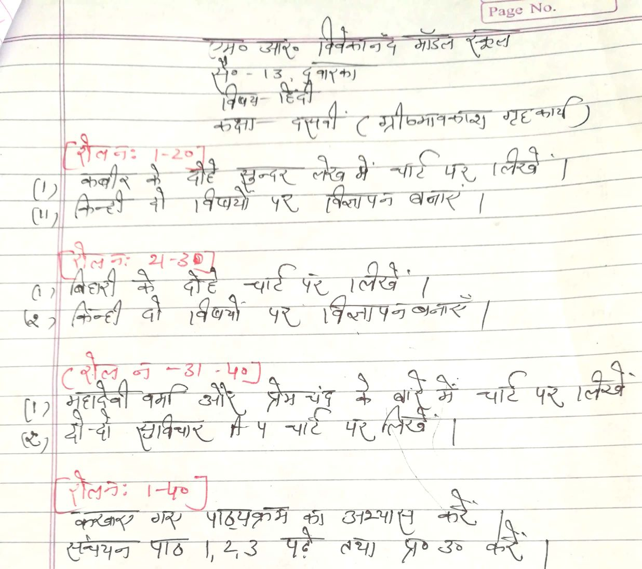

Our Expectations from Parents
Dear Parents,
Our school management and teachers try to instil soft values in our students in their daily routine
like caring and sharing , good relationships and mutual respect etc. We request all parents to reinforce such values in their wards during summer vacations and thereafter.
So please take care of the following:
1. Parents are requested to spend some quality time with their children .
2. Get some good storybooks with colourful pictures for your ward and tell your child to read them
regularly.
3. Let them sow some seeds / a plant and look after the plant regularly and watch them grow.
4. Let your ward spend minimum time in T.V , using mobile phones, internet and other electronic gadgets.
5. Encourage them to write two pages transcriptions daily to improve their handwriting .
6. Give stress on practicing one moral value daily.
7. Encourage your child to help you in small thingsrelated to Kitchen/Cleanliness.
8. Discourage your child to eat fast food like burger, pizza and carbonated drinks.
9. Allow your child to play outdoors games as it helps to make them strong.
10. Plan a holiday trip with your family for recreation.

Wishing you Happy and fruitful holidays.

Principal

