M.R VIVEKANANDA MODEL SCHOOL, Sector – 13 Dwarka
HOLIDAY HOMEWORK
CLASS – 8 (2019-20)
Dear parents,
The most awaited Summer Break is from 18^{h} May to 30th June. As per forecast by weather department the temperature will rise more and warm breeze (Loo) will blow. We suggest the following measures for your ward to remain healthy and hydrated:
- Wear cotton clothes, consume more liquids and water, go for morning walks. We want our students to utilize this time in a fruitful manner.
- Remain indoorfor most of the time, read newspapers, spend value time with elders and grandparents, help parents with daily chores, watch TV channels like National Geographic and Discovery.
Teachers have planned interesting, creative and knowledgeable home work.
Ensure that your ward does the Holiday Homework on his/her own using innovations. Guide and assist them only.

Principal
ENGLISH
1. Read any 1 of the following books and write about your favourite character in about 200-250 words (DO NOT copy from the internet):
a) Robinson Crusoe by Daniel Defoe
b) The Murder of Roger Ackroyd by Agatha Christie
c) Jurassic Park by Michael Crichton
d) To kill a Mocking Bird by Harper Lee
e) Harry Potter series by J.K. Rowling
2. Create a joke or a short story on your own and illustrate it through a colourful comic strip in not more than 4 pages.
3. Read the next 4 chapters from your supplementary reader- ‘It So Happened’ and write their summaries:
a) The Selfish Giant b) The Treasure Within
c) Princess September d) The Fight
4. No story lives unless someone wants to listen. Tell us a story of your choice through flash cards. Draw pictures on one side of the card and write the parallel story on the other side. Tie the cards together so that it is easy to flip through it.
5. Complete the assignment that has been given.
SUBJECT - SOCIAL SCIENCE
Revise all the work done in class and read newspaper daily.
Write a paragraph on explaining “ Importance of the study of History”.(do this in scrapfile)
Collect pictures , stories and information on the following:
a) The Rani of Jhansi (Roll no. 1-15)
b) Maharaja Ranjit Singh (Roll no. 16-30)
c) Tipu Sultan (Roll no.31-45)
4. Make a collage on how India shows Unity in Diversity.(do this in scrapfile)
5. Write about any 5 evironmental issues in a scrapfile. Also paste pictures of each.( do this in A-3 size sheet)
6.Visit a historical monument near you, paste your picture with monument and write its history.(do this in scrapfile)

MATHS
- Do Review exercise of Ch-1,2,3 from Maths Wisdom in A4 size sheets and practice ch-1,2,3from Maths Wisdom.
- Do activity of ch-2 and 3 in Maths Lab File.
- Do 2 value based question from each of ch- 1,2,3
- Make a decorative chart /A3 Sheet on any of the topic given on (V)
- Make a working model on following topics as per given Roll no
- Properties of Rational number(1-3)
- Representation of rational number on number line.(4-6)
- Laws of exponents (7-10)
- Square of a number by column and diagonal method.(11-13)
- Angle sum property of Quadrilateral (14-16)
- Types of Quadrilateral (17-20)
- Square and square root (21-23)
- Cube and cube root (24-26)
- Formulae of surface area and volume of 3-D figures(27-30)
- Represents 3-D figures in 2-D (31-33)
- Histogram (34-35)
- Pie chart (36-40)
SCIENCE
Make a chart and a model on the following topics:
- Roll Numbers 1-10: Solar Energy
- Roll Numbers 11-20: Agriculture and technology
- Roll Numbers 21-30: Rainwater Harvesting working model
- Roll Numbers 31-40: Wastewater treatment plant
COMPUTER
Project: Make a projecton following topics according to your Roll No.
Roll No. | Topics
1-5 | Make a model on Internet Services
6-10 | Make a chart on Google Apps
11-15 | Make a chart or model on Cloud Computing
16-20 | Make a chart of Google Apps
21-25 | Make a chart on “working computer System and explain briefly
26-30 | Make a model of Google apps
31-35 | Make model on computer Network
36 onwards | Make a chart on computer network
DRAWING
1-Draw a Monochrome Painting in A3 size sheet.
2-Make a wall Hanging with the help of cardboard and fabric paint. Decorate it also.
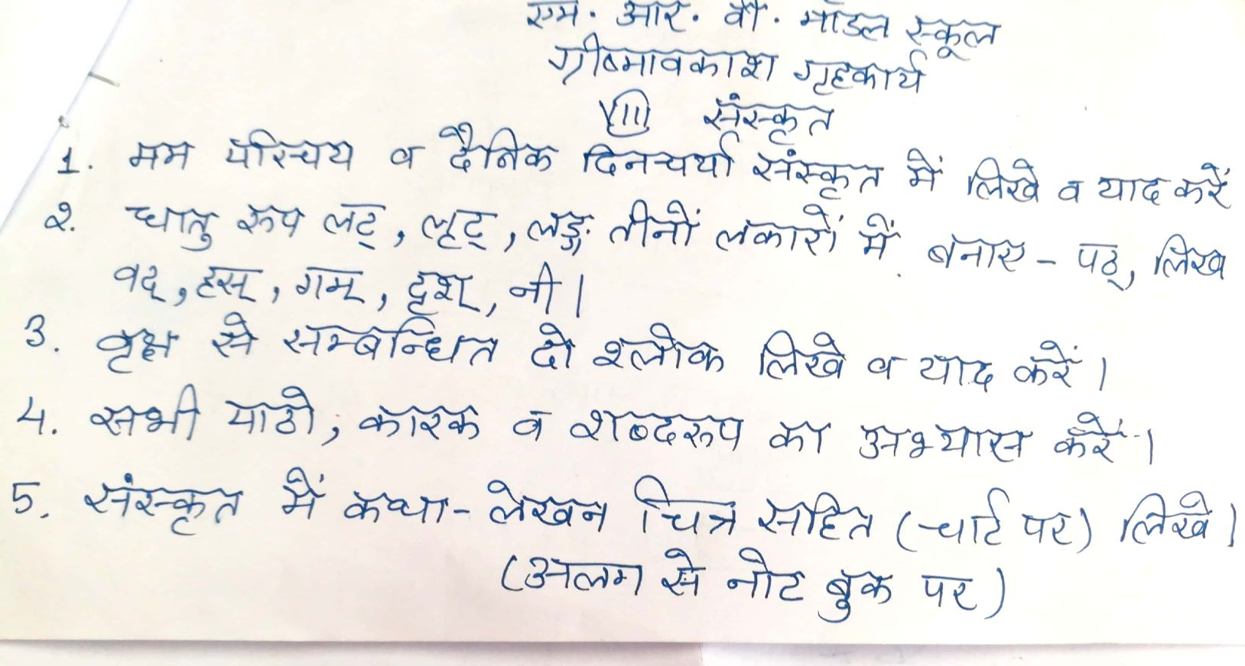

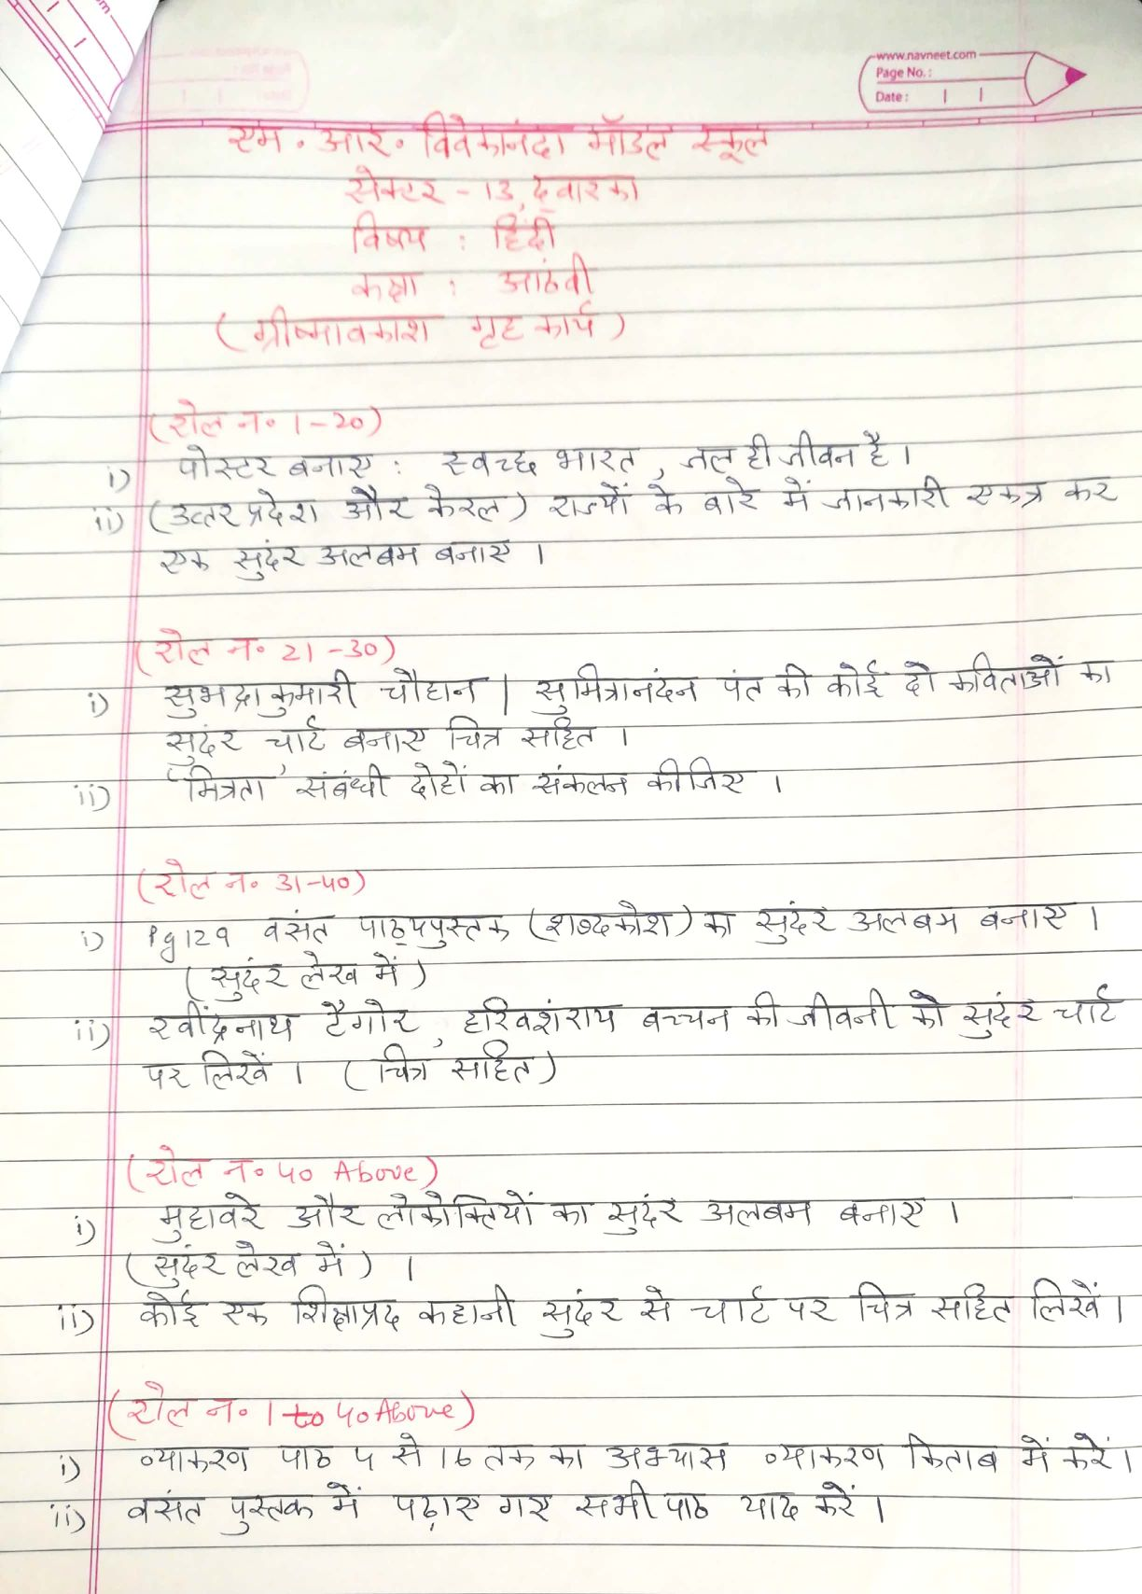

Our Expectations from Parents
Dear Parents,
Our school management and teachers try to instil soft values in our students in their daily routine
like caring and sharing , good relationships and mutual respect etc. We request all parents to reinforce such values in their wards during summer vacations and thereafter.
So please take care of the following:
1. Parents are requested to spend some quality time with their children .
2. Get some good storybooks with colourful pictures for your ward and tell your child to read them
regularly.
3. Let them sow some seeds / a plant and look after the plant regularly and watch them grow.
4. Let your ward spend minimum time in T.V , using mobile phones, internet and other electronic gadgets.
5. Encourage them to write two pages transcriptions daily to improve their handwriting .
6. Give stress on practicing one moral value daily.
7. Encourage your child to help you in small thingsrelated to Kitchen/Cleanliness.
8. Discourage your child to eat fast food like burger, pizza and carbonated drinks.
9. Allow your child to play outdoors games as it helps to make them strong.
10. Plan a holiday trip with your family for recreation.

Wishing you Happy and fruitful holidays.

Principal

