M.R VIVEKANANDA MODEL SCHOOL, Sector – 13 Dwarka
HOLIDAY HOMEWORK
CLASS – 7 (2019-20)
Dear parents,
The most awaited Summer Break is from 18^{h} May to 30th June. As per forecast by weather department the temperature will rise more and warm breeze (Loo) will blow. We suggest the following measures for your ward to remain healthy and hydrated:
- Wear cotton clothes, consume more liquids and water, go for morning walks. We want our students to utilize this time in a fruitful manner.
- Remain indoorfor most of the time, read newspapers, spend value time with elders and grandparents, help parents with daily chores, watch TV channels like National Geographic and Discovery.
Teachers have planned interesting, creative and knowledgeable home work.
Ensure that your ward does the Holiday Homework on his/her own using innovations. Guide and assist them only.

Principal
ENGLISH
1. Make a Poster on the given topics:- Woman Education(Roll no. 1-10 )
Gender Equality (Roll no. 11 -20)
Pollution (Roll no. 21-30)
Solar Energy (Roll no. 31-45)
2. Make flash cards depicting some moral story.
3. Read any book of your choice given below and write about the character of your choice.
1. Tom Sawyer
2. Huckleberry finn
3. Treasure Island
4. Panchtantra
3.Write five main headlines of English in separate notebook.
4. Complete the assignment.
5 . Learn at least five English words everyday and make sentences using them in separate notebook.
SCIENCE
1. Learn and write question answer of Chapter 1,2,3.
2. Do the following according to your roll number.
a) Prepare a model showing a set of teeth.( from roll no. 1 to 10)
b) Make a working model of human digestive system.( from roll no. 11 to 20)
c) Make a working model of heart .( from roll no. 21 to 30)
d) Make a working model of human urinary system.( from roll no. 31 to 40)
3. Make a following chart and label the diagram properly.( Take the help of basic science book)
a) Basic structure of Nephron. (page no. 101) ( roll no. 1 to 8)
b) Blood circulation in the human body .(page no. 99) ( roll no. 9 to 16)
c) The trachea branches into two bronchi which enters the two lungs.(page no. 107)(roll no.17 to 24)
d) A diagram showing all the layers of soil. (page no. 133)( roll no. 25 to 32)
e) Draw a ruminant showing four chambered stomach.( page no. 91)( roll no. 33 to 40)

SUBJECT - SOCIAL SCIENCE
1.Revise all the work done in the class and read newspaper daily.
2. Collect pictures and information on at least two temples in your locality and prepare a report. (do this in scrapfile)
3. Make a report on way to conserve water.(do this in scrapfile)
4. Collect the pictures and make a collage of famous leader, social worker, sports person. (do this in A-3 size Sheet)
5. Prepare a poster :
a) Global Warming , its causes and consequences.(Roll no. 1-20)
b) Gender Sensitization .(Roll no. 21- 40)
6. Make a model :
a)Volcanic Eruption (Roll no. 1-20)
b) Interior of the earth(Roll no. 21-40)
MATHS

- Do Review exercise of Ch-1,2,3,10 from C P A Maths in A4 size sheets and practice Ch-1,2,3,10 from C P A.
- Do activity of ch-3 and 10 in Maths Lab File.
- Do 2 value based question from each of ch- 1,2,3
- Make a decorative chart on any of the topic given on (V)
- Make a working model on following topics as per given Roll no
- Properties of Integers ( 1-3)
- Representation of Rational number on number line.(4-6)
- Laws of exponents (7-9)
- Pythagoras property of right angled triangle.(10-12)
- Bar graph and Probability based on cards and dice.(13-16)
- Types of Triangles,angle and lines(17-20)
- Congruence of triangle (21-23)
- Types of angles formed by a transversal with two lines (24-26)
- Formulae of perimeter and area of 2-D figure.(27-30)
- Represents 3-D figures in 2-D (31-33)
- Algebraic expression (34-36)
- Symmetrical figures and shapes.(37-40)
COMPUTER
Project: Make a project on following topics according to your Roll No.
Roll No. | Topics
1-5 | Make a chart paper of Computer System
6-10 | Make a model of “Biometric Device”
11-15 | Make a model on Different types of websites
16-20 | Make a banner on A3 sheet on “Maintain discipline in Computer Lab”
21-25 | Make a A3 Sheet on Social Media
26-30 | Make a chart or A3 sheet on E-Business(eg. Shopping website)
31 onwards | Good Manners in Computer Lab
DRAWING
1-Make Alpana (Rangoli) with pastel and flourcent sheet (cut and paste). Decorative it also.
2-Draw a landscape and complete with sketch pens in Drawing File.

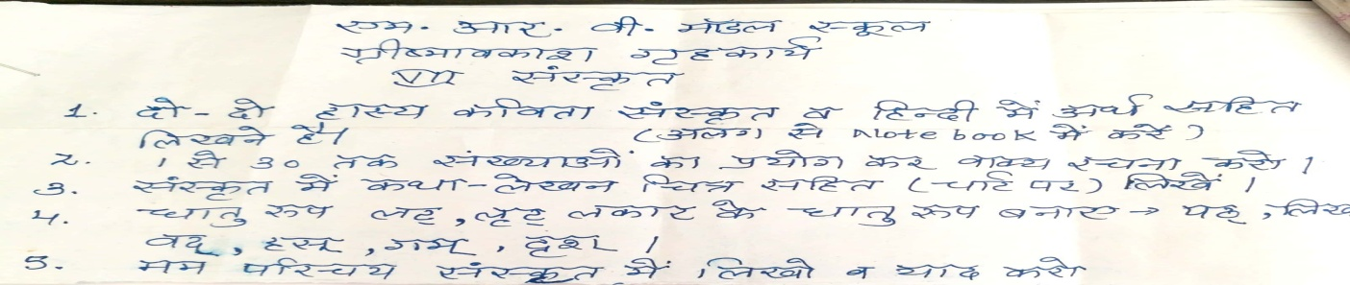
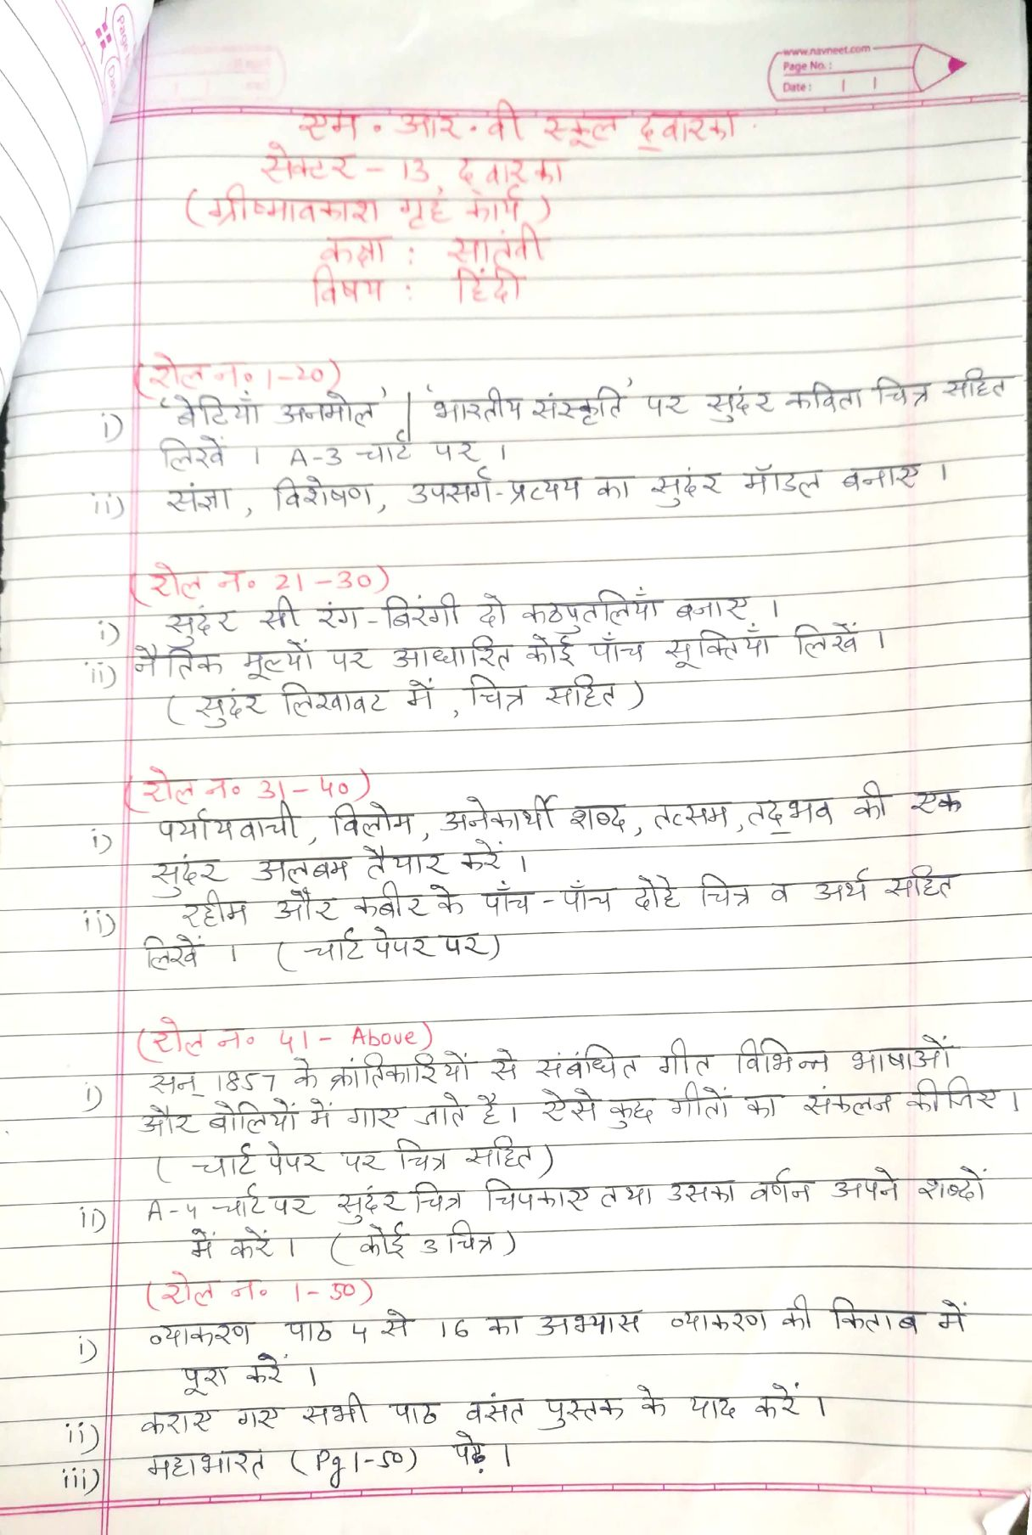
Our Expectations from Parents
Dear Parents,
Our school management and teachers try to instil soft values in our students in their daily routine
like caring and sharing , good relationships and mutual respect etc. We request all parents to reinforce such values in their wards during summer vacations and thereafter.
So please take care of the following:
1. Parents are requested to spend some quality time with their children .
2. Get some good storybooks with colourful pictures for your ward and tell your child to read them
regularly.
3. Let them sow some seeds / a plant and look after the plant regularly and watch them grow.
4. Let your ward spend minimum time in T.V , using mobile phones, internet and other electronic gadgets.
5. Encourage them to write two pages transcriptions daily to improve their handwriting .
6. Give stress on practicing one moral value daily.
7. Encourage your child to help you in small thingsrelated to Kitchen/Cleanliness.
8. Discourage your child to eat fast food like burger, pizza and carbonated drinks.
9. Allow your child to play outdoors games as it helps to make them strong.
10. Plan a holiday trip with your family for recreation.

Wishing you Happy and fruitful holidays.

Principal

