M.R VIVEKANANDA MODEL SCHOOL, Sector – 13 Dwarka
HOLIDAY HOMEWORK
CLASS – 6 (2019-20)
Dear parents,
The most awaited Summer Break is from 18^{h} May to 30th June. As per forecast by weather department the temperature will rise more and warm breeze (Loo) will blow. We suggest the following measures for your ward to remain healthy and hydrated:
- Wear cotton clothes, consume more liquids and water, go for morning walks. We want our students to utilize this time in a fruitful manner.
- Remain indoorfor most of the time, read newspapers, spend value time with elders and grandparents, help parents with daily chores, watch TV channels like National Geographic and Discovery.
Teachers have planned interesting, creative and knowledgeable home work.
Ensure that your ward does the Holiday Homework on his/her own using innovations. Guide and assist them only.

Principal
ENGLISH
1. Read the newspaper daily and write important news in a separate copy. Also make a dictionary of the difficult words. It should ne colourful and creative.
2. Read the stories ‘Don Quixote’ and ‘Godaan’ and make a flip book of each. Also write the review of the stories on A4 size sheet.
3. Make flash cards on the topic given according to your roll number.
a. Sentences roll no. 1to 10
b. Nouns roll no. 11 to 20
c. Noun- Gender roll no. 21 to 30
d. Countable and Uncountable Nouns roll no. 31 to 45
4. Make a poster according to your roll number.
a. Save Earth roll no. 1to 10
b. Good Manners roll no. 11 to 20
c. Benefits of gadgets roll no. 21 to 30
d. Save Water roll no. 31 to 45

MATHS
Q1. Do the review exercise of Ch-1, 2, 10 and 11 in a separate notebook.
Q2. Write names of ten countries and their population in figures and words using Indian and International System of Numeration.
Q3.Make a foldable activityon:
- Properties of Multiplication. (Roll no. 1 to 5)
- Circle and its parts. (6 to 10)
- Triangles and its classification based on sides and angles (11 to 15)
- Properties of Integers (16 to 20)
- Types of fractions (21 to 25)
- Divisibility rules (26 to 30)
- Types of algebraic expressions (31 to 35)
- Types of quadrilaterals and its properties (36 to 40)
- Symmetry (41 to 45)
Q4. Make a chart on any one topic given above in Q3 on A3 size sheet.
SCIENCE
1. Learn and write question answer of Chapter 1,2,3.
2. Do the following according to your roll number.
a) Make a chart showing different parts of flower. (from roll no. 1 to 10)
b) Make a working model of the skeleton system.( from roll no. 11 to 20)
c) Make a chart showing the bones of leg.( from roll no. 21 to 30)
d) Make a working model showing water cycle.( from roll no. 31 to 35 )
e) Make a firki.( page no. 164of basic science ) ( from roll no. 36 to 42 )
3. Collect some coloured pieces of cloth from the Tailor shop and prepare atleast five birds and decorate them
With gota, beads, stars etc. and shape them Into a wall hanging.
SUBJECT– SOCIAL SCIENCE
1-Revise all the work done in the class .
2-Read news paper daily and collect the weather report .
3-Draw or paste different ancient tools and their functions. (do this in scrapfile)
4-Collect the pictures related to sources of history.(do this in scrapfile)
5-Write 100 words each of the following: (do this A -3 size sheet)
Dr. B R Ambedkar ( Roll no. 1 -15)
- Mahatma Buddha (Roll no. 16 -25)
- Mahatma Gandhi (Roll no. 26 -35)
- Jawaharlal Nehru (Roll no. 36 -45)
6-Make a model :
- Globe ( Roll no. 1-20)
- Solar system (Roll no. 21-35)
- Latitudes and Longitude (Roll no.36 -45)

COMPUTER
Project: Make a project on following topics according to your Roll No.

Roll No. | Topics
1-5 | PASACALINE CALCULATOR
6-10 | Make a chart on “Types of computer”
11-15 | ABACUS
16-20 | Make a banner on A3 sheet on “Silent in Computer Lab”
21-25 | Make a model or chart of Google search engine
26-30 | Make screen of window 10
31 -33 | Make a chart paper on father of computer , Paste a picture and Explain
34 onwards | Make A3 sheet on topic “ need of computer lab”

CLASS VI
1-Make a file cover with the handmade sheet as shown as page no. 65 in book.
2-Make a decorative Envelope with the help of handmade sheets.

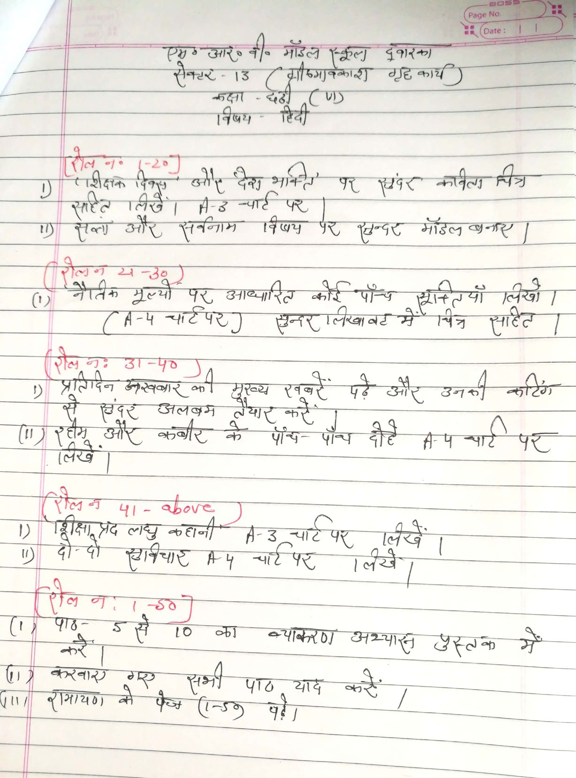

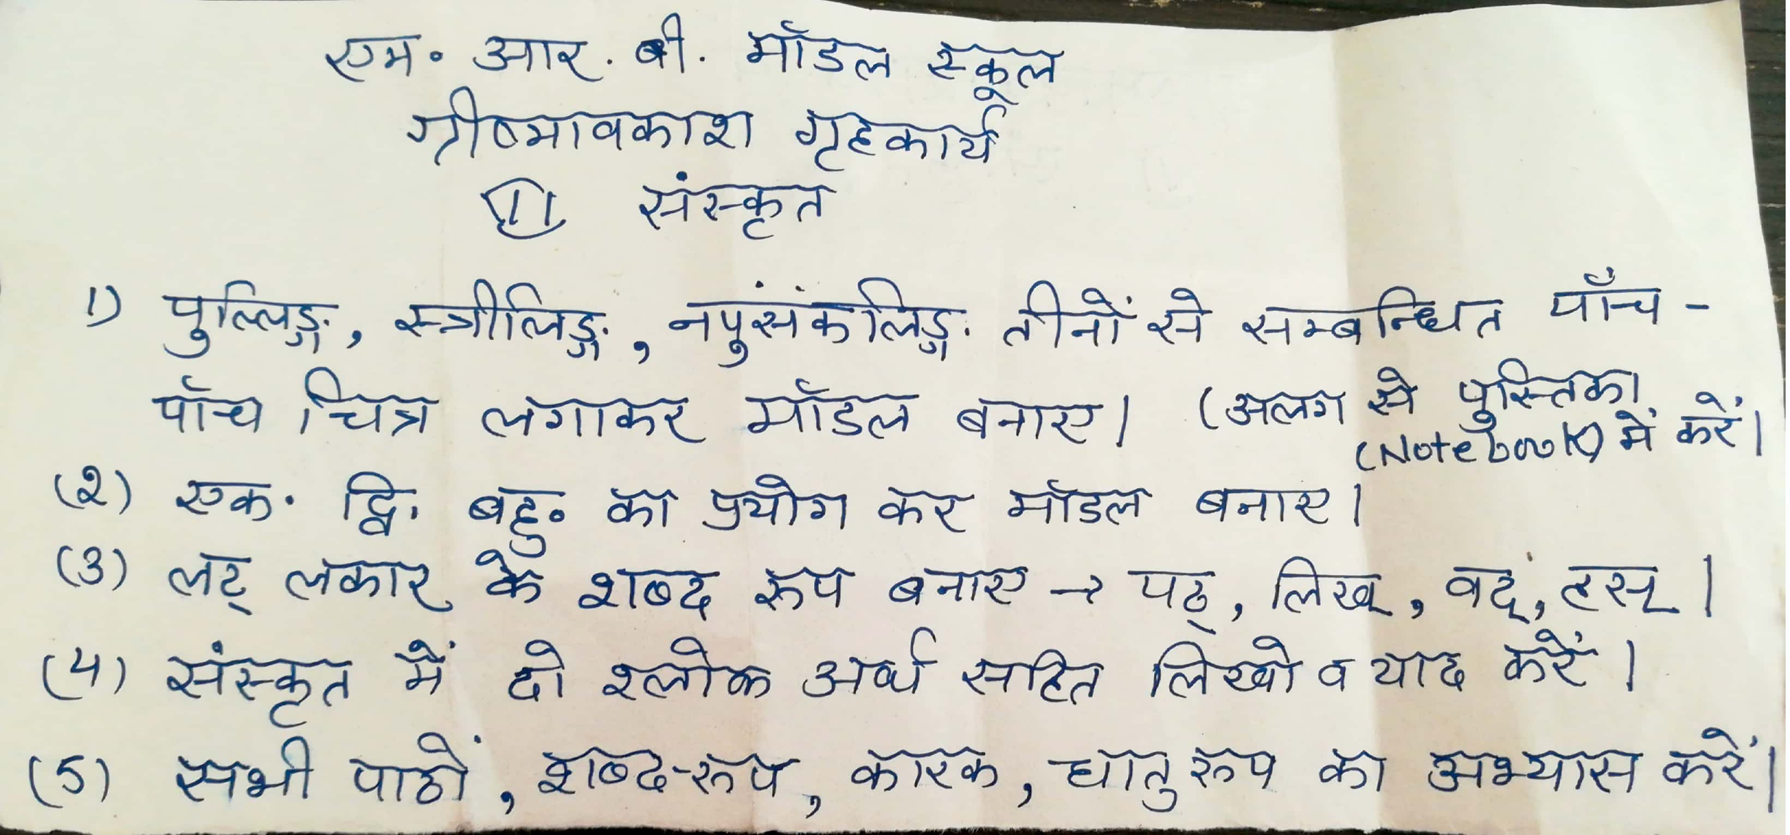
Our Expectations from Parents
Dear Parents,
Our school management and teachers try to instil soft values in our students in their daily routine
like caring and sharing , good relationships and mutual respect etc. We request all parents to reinforce such values in their wards during summer vacations and thereafter.
So please take care of the following:
1. Parents are requested to spend some quality time with their children .
2. Get some good storybooks with colourful pictures for your ward and tell your child to read them
regularly.
3. Let them sow some seeds / a plant and look after the plant regularly and watch them grow.
4. Let your ward spend minimum time in T.V , using mobile phones, internet and other electronic gadgets.
5. Encourage them to write two pages transcriptions daily to improve their handwriting .
6. Give stress on practicing one moral value daily.
7. Encourage your child to help you in small thingsrelated to Kitchen/Cleanliness.

8. Discourage your child to eat fast food like burger, pizza and carbonated drinks.
9. Allow your child to play outdoors games as it helps to make them strong.
10. Plan a holiday trip with your family for recreation.

Wishing you Happy and fruitful holidays.

Principal

