M.R VIVEKANANDA MODEL SCHOOL, Sector – 13 Dwarka
HOLIDAY HOMEWORK
CLASS – V (2019-20)
Dear parents,
The most awaited Summer Break is from 18^{h} May to 30th June. As per forecast by weather department the temperature will rise more and warm breeze (Loo) will blow. We suggest the following measures for your ward to remain healthy and hydrated:
- Wear cotton clothes, consume more liquids and water, go for morning walks. We want our students to utilize this time in a fruitful manner.
- Remain indoor for most of the time, read newspapers, spend value time with elders and grandparents, help parents with daily chores, watch TV channels like National Geographic and Discovery.
Teachers have planned interesting, creative and knowledgeable home work.
Ensure that your ward does the Holiday Homework on his/her own using innovations. Guide and assist them only.

Principal
ENGLISH
1. Read the newspaper daily and note down 3 headlines every day in a small notebook. Take the help of a dictionary if the meaning of a word is unclear.
2. Read any 1 of the following books and write about your favourite character in about 150 words (DO NOT copy it down from the internet) :
a) Heidi
b) Black Beauty
c) The Adventures of Pinocchio
d) Arabian Nights
e) Alice in Wonderland
3. Write the ingredients and a step-by-step recipe of your favourite dish in your own words on a colourful A4 size sheet. Prepare the dish with the help of your family members. Click a picture of the delicious dish and attach it to the recipe.
4. As suggested by the Maharaja of Travancore, not all waste should be thrown away. Collect a few waste-items from day to day life and make something creative out of it. The best out of the waste will be displayed in the exhibition.
5. Complete the assignment that has been given.

SCIENCE
Roll No-1 to 8
1)Learn question and answers and Exercises of Chapter-1 and 3 and do thorough reading.
2)Make a model- Making a Ribcage using paper cutting method (thing needed- chart paper, scissors, adhesive tape).
3)Write a poem on A4 sheet about the functions of Internal body parts.

Roll No-9 to 16
1)Learn question and answers and Exercises of Chapter-1 and 3 and do thorough reading.
2)Make a table in a scrap file to identify the parts of India where the different types of food and cash crops are grown. Show it on map only.
3)Ask a gardener in your neighbourhood about the tools and methods used to grow flowering plants. Draw or paste tools used and different methods used to grow flowering plant. Write their uses in scrap file.

Roll No-17 to 24
1)Learn question and answers and exercises of Chapter-1 and 3 and do thorough reading.
2) Model Making-Make a cactus using sponge.
Materials required- sponge, wax paper, glass bowl, water, notebook, pencil, child safe scissors.
3) Write on a A3 sheet to classify food items as roots and stems. Write how Roots and stems different from each other. Paste pictures and identify them as roots and stems.

Roll No-25 to 32
1)Learn question and answers and exercises of Chapter-1 and 3 and do thorough reading.
2) You are now 10 to 11 years old. From the time you were born your parents would have taken you to the hospital at different times to get you vaccinated. Speak to your parents about it and make a chart to show the age when you went to the doctor and for which vaccination. Your chart should display the age, the vaccination received and the disease it protect you from.

Eg-
Serial No. | Year when administrated (Age) | Name of the vaccine | Protection against (which disease)
1.
2.
3.
3) By using different colours of clay make five sense organs. Paste them on a thermocol and write how they help to be the windows of our brain.
Roll No-33 to 40
1) Learn question and answers of Chapter-1 and 3 and do thorough reading.
2)Make skeleton with the help of different colours of clay and label them properly and paste it on a thermocol.
3)Design a poster on the following topics-(a) Save water (b) Save plants

MATHS
Q1. Write the population of 10 different states of India in figures and in words using Indian and International System of Numeration.
Q2. Do 5 sums daily of addition, subtraction and estimation.
Q3. With cardboard make a cube or cuboid. (Roll no.-1 to 10)
Q4. Make a chart of Roman Numerals 1 to 30 on A3 size sheet. (Roll no.-11 to 20)
Q5. Make different types of angles (acute, right etc.) using matchsticks or colourful straws on A3 size sheet. (Roll no.- 21 to 30)
Q6. Make a model of triangular pyramid.(Roll no.- 31 onwards)

Computer
Roll no.1 to 15
a)Make a chart showing Generation of Computers (A3 size ) with Pictures.
Roll no.16 to 20
b)Make a chart on memory devices.
Roll no.21 to 40
c)Make a 3D model on Google Icon, Facebook, Twitter.
-Make a chart of Use of Internet.
Social Science
1 ) Visit Nehru Planetarium and collect information about our solar system. Write a report on your report on A4 size sheet.
2) Name any five sports women of India and write about their achievements on a chart. Also paste their pictures.
3) Make a project on Golconda Fort. Collect information about:
-when it was built
-who built the fort
-architectural speciality
-people living inside the fort etc
- also collect the various pictures of the fort and paste them in the project file.
4) Make a Model
Roll no 1-10 TajMahal
1-20 Red Fort
21-30 India Gate
31 onwards QutubMinar
COMPUTER
Roll no.1 to 20
a)Make a chart on rules to be followed in Computer Lab (10 rules).
b)Make a model of any one input and output device.
Roll no. 21 to 34
b)Make a model of ATM machine .
Roll no. 35 to 45
c) Paste the picture of various types of Input devices and output devices and label them on A3 size sheet.
DRAWING
CLASS V
1-Make a Wall Hanging with the help of any waste material.
2-Draw and colour Monochrome painting in Drawing File.

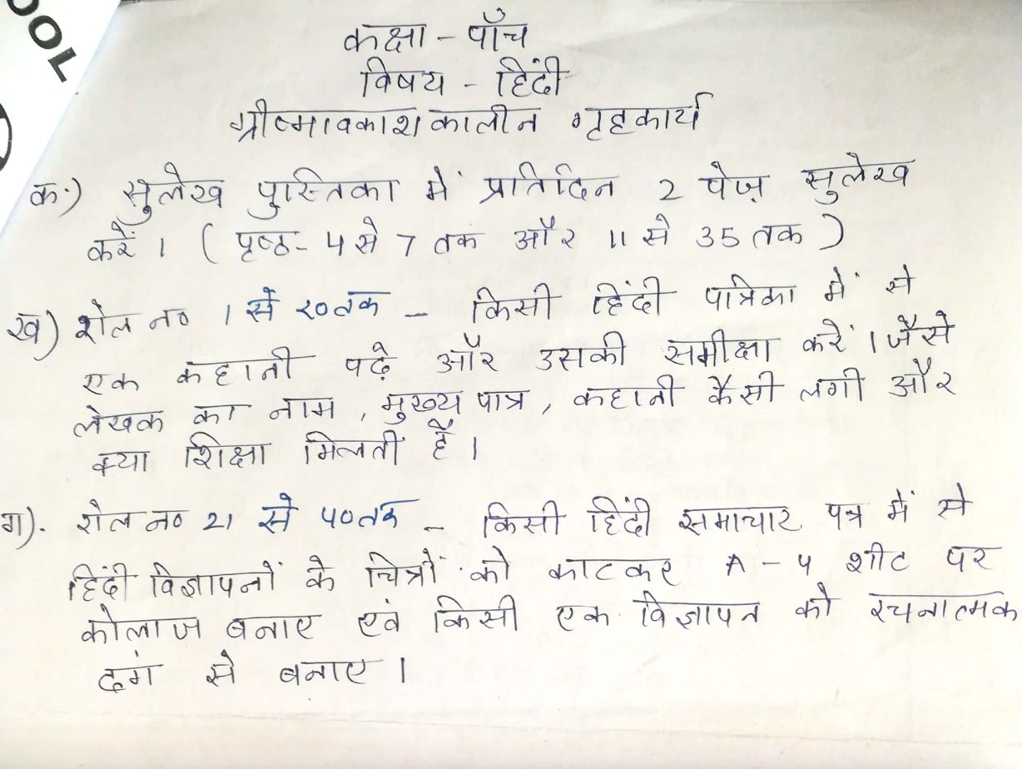
Our Expectations from Parents
Dear Parents,
Our school management and teachers try to instil soft values in our students in their daily routine
like caring and sharing , good relationships and mutual respect etc. We request all parents to reinforce such values in their wards during summer vacations and thereafter.
So please take care of the following:
1. Parents are requested to spend some quality time with their children .
2. Get some good storybooks with colourful pictures for your ward and tell your child to read them
regularly.
3. Let them sow some seeds / a plant and look after the plant regularly and watch them grow.
4. Let your ward spend minimum time in T.V , using mobile phones, internet and other electronic gadgets.
5. Encourage them to write two pages transcriptions daily to improve their handwriting .
6. Give stress on practicing one moral value daily.
7. Encourage your child to help you in small thingsrelated to Kitchen/Cleanliness.
8. Discourage your child to eat fast food like burger, pizza and carbonated drinks.
9. Allow your child to play outdoors games as it helps to make them strong.
10. Plan a holiday trip with your family for recreation.

Wishing you Happy and fruitful holidays.

Principal

