M.R VIVEKANANDA MODEL SCHOOL, Sector – 13 Dwarka
HOLIDAY HOMEWORK
CLASS – III (2019-20)
Dear parents,
The most awaited Summer Break is from 18^{h} May to 30th June. As per forecast by weather department the temperature will rise more and warm breeze (Loo) will blow. We suggest the following measures for your wardto remain healthy and hydrated:
- Wear cotton clothes, consume more liquids and water, go for morning walks. We want our students to utilize this time in a fruitful manner.
- Remain indoorfor most of the time, read newspapers, spend value time with elders and grandparents, help parents with daily chores, watch TV channels like National Geographic and Discovery.
Teachers have planned interesting, creative and knowledgeable home work.
Ensure that your ward does the Holiday Homework on his/her own using innovations. Guide and assist them only.

Principal
ENGLISH
1) Do one page of cursive writing daily in cursive writing book.
2) Write 10 countable and 10 uncountable nouns on A4 size sheet.
3) Reading enhances knowledge and provides good opportunity to increase our vocabulary. Read any two stories of your choice. Write their summaries and new words with their meanings in the notebook.
4) Write a poem of your choice and draw a picture related to it on A3 size sheet.
5) Revise all the lessons done in the class room.

SCIENCE
1) Learn question and answers of Chapter- 2(The Plant Fairy) , 3 (Water O’ Water) and 6 (Foods we Eat) and do thorough reading.
2) Paste 10 different types of leaves in a scrap file and name the plant it belongs.
3) Make a chart and draw the plants as medicine, perfumes, oils ,fruits and vegetables.
4) On A4 size sheet write steps on topic “how to save water”.

SOCIAL SCIENCE

1)Read Chapters coming in Mid term and write ten difficult words from each chapter in practice notebook.
2)Learn question and answers done in notebook and workbook.
3)PracticeStates and their capitals on India ‘s Political map.(Use Atlas )

ROLL NO. 1 TO 10:
1)On A3 size sheet write important facts related to our Earth (Maximum 10)
2)Make a poster on your favourite season .
3)Make a model of any animal who live on land.

ROLL NO. 11 TO 20:
1)”Family is like branches on a tree. We all grow in different directions, yet our roots remain as one. “
Make a family photo album using a scrapbook . Paste photo of each family member along with their name. Take their interview and write their age, hobbies, likings, favourite dance , Movie, Songs etc.
2)Make a poster on your favourite festival.
3)Make a model of any animal who live in water.

ROLL NO. 21 TO 36:
1)School is the second home and teachers are second mothers. School is like an extended family . Write a message expressing your feedings towards school on A4 size sheet.
2)Make a poster on ‘Save Girl Child’ or ‘SwacchhtaAbhiyan’ or ‘Stop Child Labour’.
3)Make a model of any bird.
MATHS

Q1. Do 5 sums daily of addition and subtraction in a separate notebook.
Q2. Write the numbers of ten cars in figures and words.
Q3. Make a mask using different shapes. (Roll no.-1 to 10)
Q4. Make a working model of a clock. (Roll no -11 to 20)
Q5. Make a rangoli using different shapes on A3 size sheet. Use the cutouts of the shapes. (Roll no.-21 to 30)
Q6. Draw 5 things which have mirror halves on A3 size sheet. (Roll no.- 31 onwards)
COMPUTER
Roll No. 1 to 20
a)Make a 3 D keyboard.
Roll No.21 to 30
b)On A3 size sheet paste the pictures of different parts of computer.
Roll No. 31 onwards
c)Make a 3D Joystick .
DRAWING
CLASS III
1-Draw and colour Tree landscape in your drawing file .
2-Do page no. 8,6, in your File.
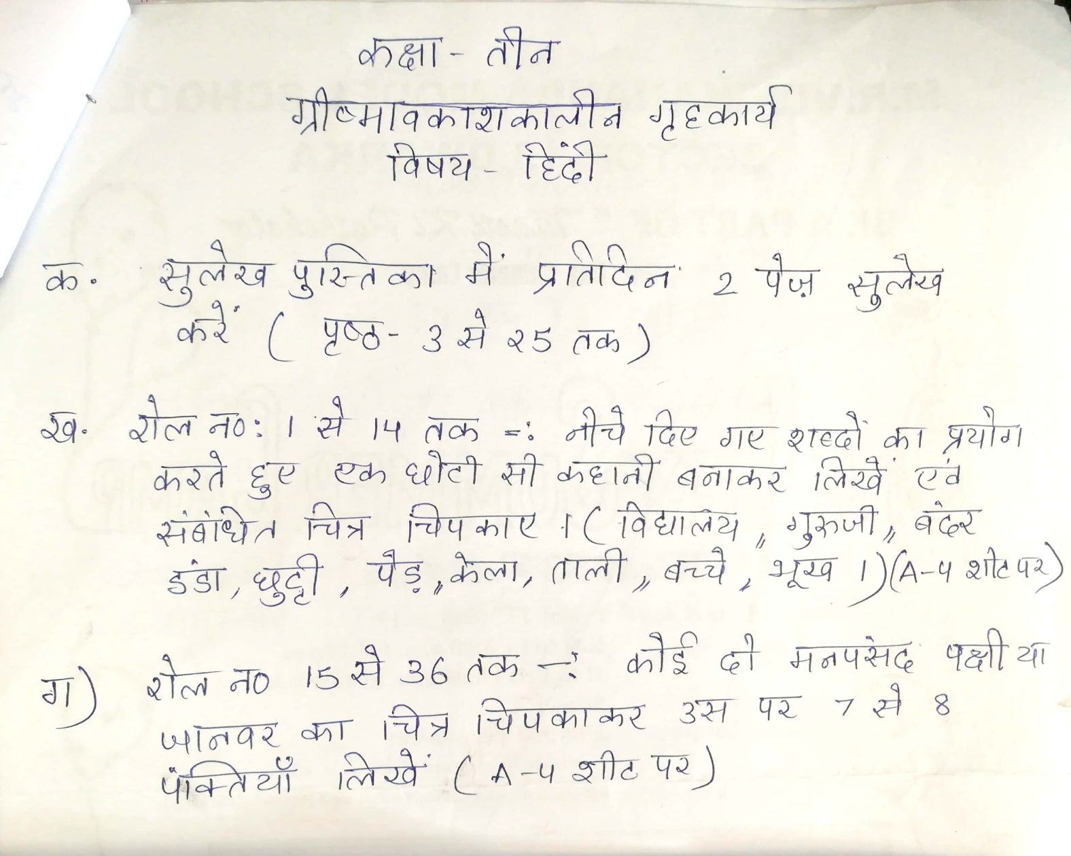

Our Expectations from Parents
Dear Parents,
Our school management and teachers try to instil soft values in our students in their daily routine
like caring and sharing , good relationships and mutual respect etc. We request all parents to reinforce such values in their wards during summer vacations and thereafter.
So please take care of the following:
1. Parents are requested to spend some quality time with their children .
2. Get some good storybooks with colourful pictures for your ward and tell your child to read them
regularly.
3. Let them sow some seeds / a plant and look after the plant regularly and watch them grow.
4. Let your ward spend minimum time in T.V , using mobile phones, internet and other electronic gadgets.
5. Encourage them to write two pages transcriptions daily to improve their handwriting .
6. Give stress on practicing one moral value daily.
7. Encourage your child to help you in small thingsrelated to Kitchen/Cleanliness.
8. Discourage your child to eat fast food like burger, pizza and carbonated drinks.
9. Allow your child to play outdoors games as it helps to make them strong.
10. Plan a holiday trip with your family for recreation.

Wishing you Happy and fruitful holidays.

Principal

