M.R. VIVEKANANDA MODEL SCHOOL, Sector – 13 Dwarka
HOLIDAY HOMEWORK
CLASS – II (2019-20)
Dear parents,
The most awaited Summer Break is from 18^{h} May to 30th June. As per forecast by weather department the temperature will rise more and warm breeze (Loo) will blow. We suggest the following measures for your wardto remain healthy and hydrated:
- Wear cotton clothes, consume more liquids and water, go for morning walks. We want our students to utilize this time in a fruitful manner.
- Remain indoorfor most of the time, read newspapers, spend value time with elders and grandparents, help parents with daily chores, watch TV channels like National Geographic and Discovery.
Teachers have planned interesting, creative and knowledgeable home work.
Ensure that your ward does the Holiday Homework on his/her own using innovations. Guide and assist them only.

Principal

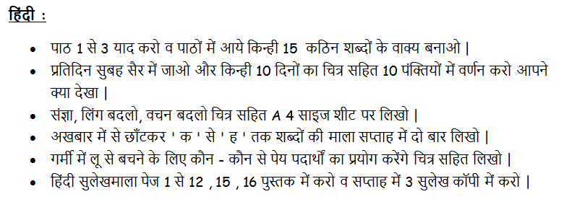

English:
- Do 15 pages of handwriting in a separate notebook.
- Read newspaper daily and write at least 20 Naming Words on a A4 coloured sheet. Categorize them into common and proper noun and paste pictures.
- Make a decorative wall hanging of word chain. Start your chain with any word and continue it with next word starting with the last letter of previous word like wall - lamp - pot – toy and so on. Also, paste pictures.
- Draw an animal on A4 sheet, decorate it and write 05 facts about it.
- Design following charts on A3 sheet according to your roll no.
    - 1 to 10 Opposites
    - 11 to 15 change the Gender
    - 16 to 20 Singulars and Plurals
    - 21 to 30 Common and proper Noun
    - 31 to 40 Classroom rules
Mathematics:

- Number names - 101 to 150.
- Learn and Write tables 2 to 12(2 times).
- Draw 2D Shapes and 3D Shapes and colour it in notenook.
- Make a beautiful collage or rangoli design on a coloured A-3 size sheet using various geometrical shapes.
- Make a model of an object related to 3D shapes, e.g. dice, pen stand, etc.
- Draw pictures of 5 long and 5 round objects on A3 sheet.
EVS:

- Make a photo frame using waste material and paste a family photo in it.
- On a scrap book, paste or draw some pictures of your favourite things( toy, place, fruit, colour etc) and write few lines about it.
- On A3 sheet draw a plant and label its pictures.
- Make colourful and beautiful charts according to your Roll nos.
Roll no 1 to 6 - Types of families and My school
Roll no 7 to 12 - Internal body organs and Means of Transport.
Roll no 13 to 18 - Healthy food and People who help us.
Roll no 19 to 24 - Traffic signals and Neighbourhood.
Roll no 25 to 30 - Types of plants and Aquatic animals.
Roll no 31 to 36 - Festivals and Types of animals.
Roll no 37onwards - Seasons and Festivals.

G.K.:

- Collect or make national flags of 10 different countries along with names and paste them on a colourful chart paper.

Computer:

- A computer is an electronic machine that processes data. Computer works very fast. It saves your time and energy. It does not make mistakes. It can remember a lot of things. The basic parts or components of the computer are mentioned in the given picture. Choose any one of your favourite part from the list and design a beautiful Model.
- Collect pictures of various places where computers are used and make a collage of these pictures on a colourful A3 sheet.
- Our Expectations from Parents
- Dear Parents,
- Our school management and teachers try to instil soft values in our students in their daily routine
- like caring and sharing , good relationships and mutual respect etc. We request all parents to reinforce such values in their wards during summer vacations and thereafter.
- So please take care of the following:
- 1. Parents are requested to spend some quality time with their children .
- 2. Get some good storybooks with colourful pictures for your ward and tell your child to read them
- regularly.
- 3. Let them sow some seeds / a plant and look after the plant regularly and watch them grow.
- 4. Let your ward spend minimum time in T.V , using mobile phones, internet and other electronic gadgets.
- 5. Encourage them to write two pages transcriptions daily to improve their handwriting .
- 6. Give stress on practicing one moral value daily.
- 7. Encourage your child to help you in small thingsrelated to Kitchen/Cleanliness.
- 8. Discourage your child to eat fast food like burger, pizza and carbonated drinks.
- 9. Allow your child to play outdoors games as it helps to make them strong.
- 10. Plan a holiday trip with your family for recreation.

- Wishing you Happy and fruitful holidays.

Principal

