M.R VIVEKANANDA MODEL SCHOOL, Sector – 13 Dwarka
HOLIDAY HOMEWORK
CLASS – K.G. (2019-20)
Dear parents,
The most awaited Summer Break is from 18^{h} May to 30th June. As per forecast by weather department the temperature will rise more and warm breeze (Loo) will blow. We suggest the following measures for your wardto remain healthy and hydrated:
- Wear cotton clothes, consume more liquids and water, go for morning walks. We want our students to utilize this time in a fruitful manner.
- Remain indoorfor most of the time, read newspapers, spend value time with elders and grandparents, help parents with daily chores, watch TV channels like National Geographic and Discovery.
Teachers have planned interesting, creative and knowledgeable home work.
Ensure that your ward does the Holiday Homework on his/her own using innovations. Guide and assist them only.

Principal

Do all the written work in 3 in 1 notebook .
ENGLISH
- Listen and enjoy with the help of parents:-
- The gingerbread man
- Little red hen
- Cinderella
- Snow white
- The foolish lion
Make a face mask of your favourite character.
WRITTEN WORK :-
- Do practice of Aa to Zz.
- Do practice of vowel ‘a’ ( once in a week )
- English book :- Do page number 11, 12,13, 14,21,22,23
For reading practice :- page number 24 ,25,and 26.

HINDI
- Do practice of क - ण (5times )
कखगघ ङ
चछजझ ञ
टठडढण

Do practice ofदोअक्षरवालेशब्द I

- Hindi book :- Do page number 6,7,8,9,10,11

MATHEMATICS
- Fun activity with shapes .Make Figure of a clown using various shapes ( circle , square ,triangle , etc .)
WRITTEN WORK :-
- Do practicecounting 1 to 50 (5 times )
- Backward counting 50-1 ( 5 times )
- Do practice of After/ before /between . 1 to 50 ( 5 times )
- Maths Book :- page number 32 , 37, 40,44,47,51 .

EVS

- On a A3 Size sheet draw a beautiful scenery using waste material and write at least five lines on how you can save nature /help your society .
- Make a wall hanging (paste picture or write quotes 0on healthy eating habits .
- EVS BOOK:- page number 5, 7, 13, 15 .

- Learn questioner given .

- Make a doll using waste material like Pepsi -can , button , shuttle cock , talcum powder bottles, buttons etc .

- The 3 R ‘s of Summer . . .
READ, RELAX and RENEW
- Play dress up
- Nature walk
- Take a bus /car ride
- Play frisbee
- Jump rope
- Play hopscotch (stapu )
- Play with ball
- Go out for ice -cream
- Read books and comics
- Go for a family outing
- Go to the water park
- Have a dance party
- Make a paper boat

- Visit India gate and children’s park
- Healthy discussion with parents on moral values .
- Fun games with family .

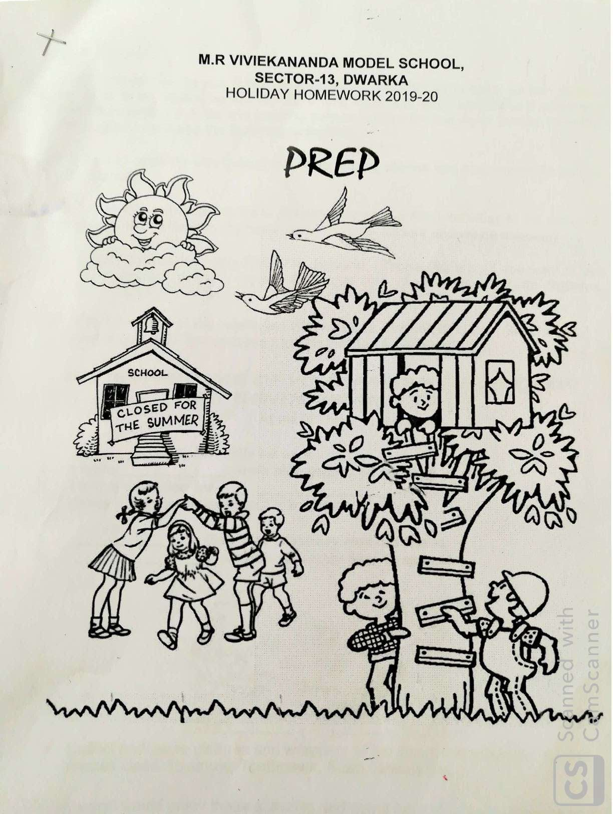

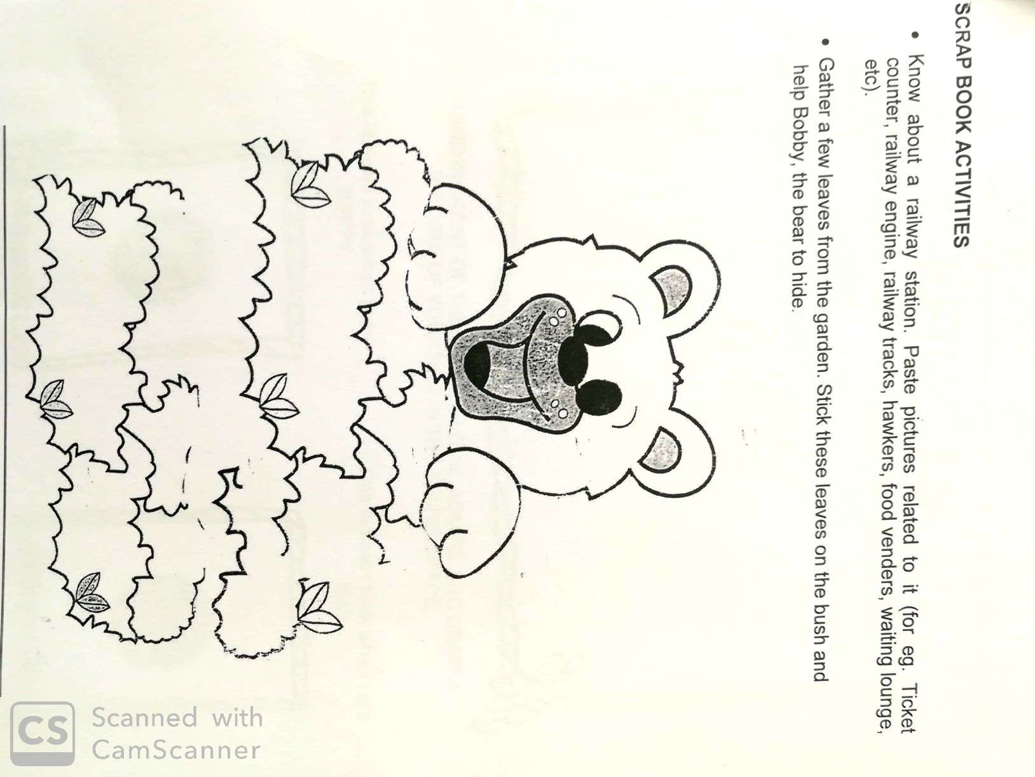

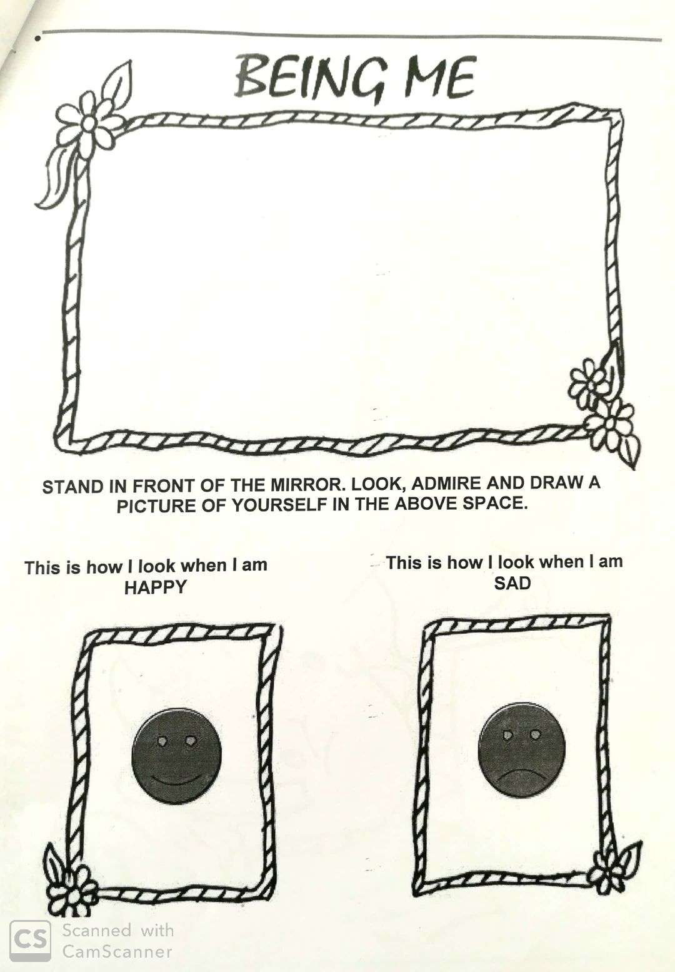

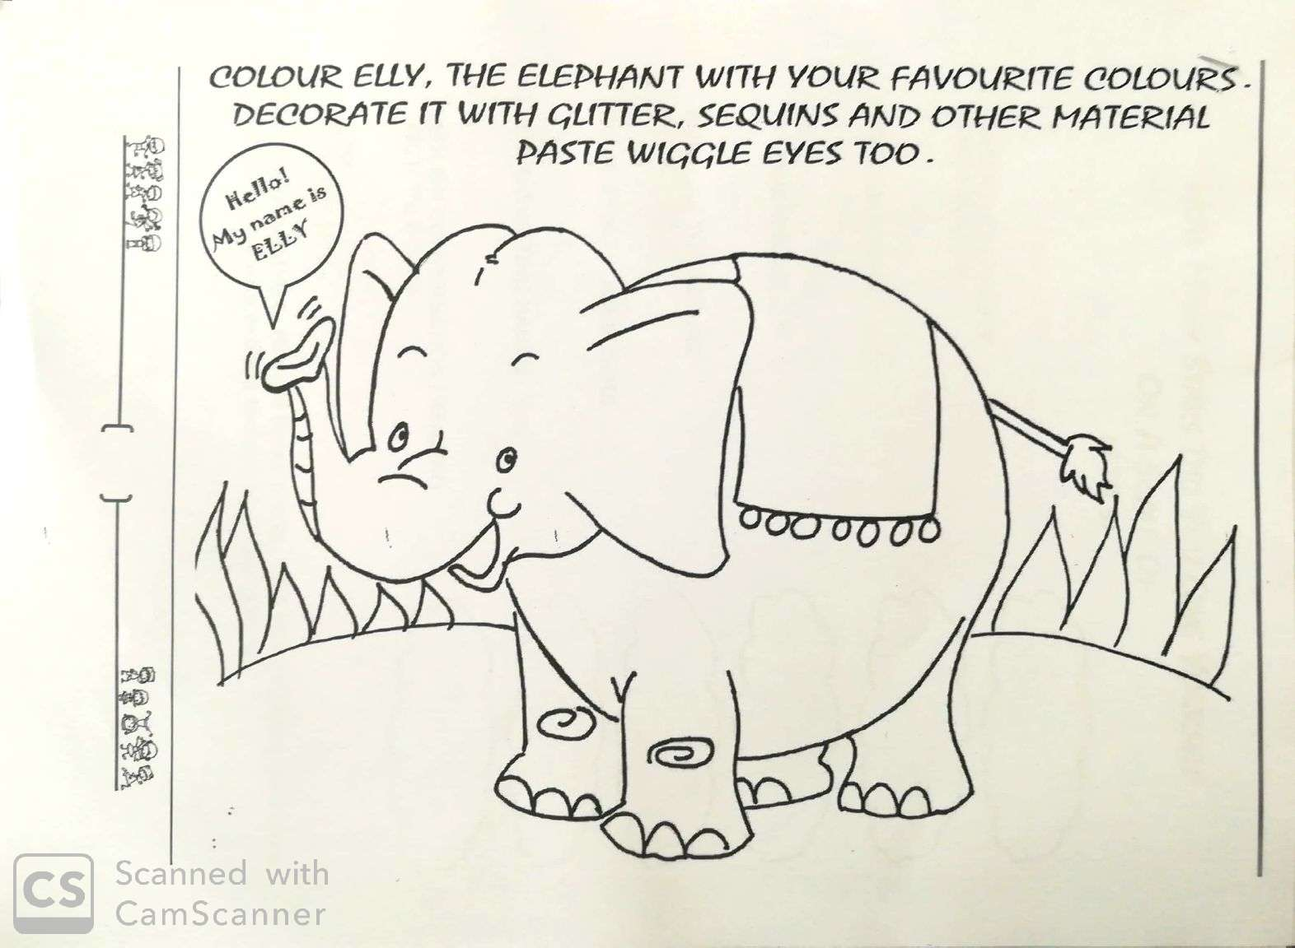
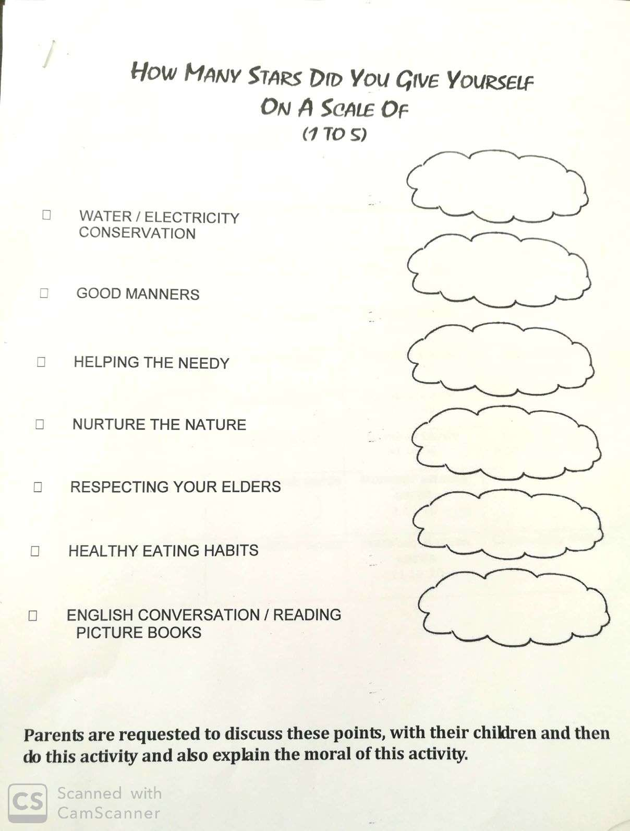

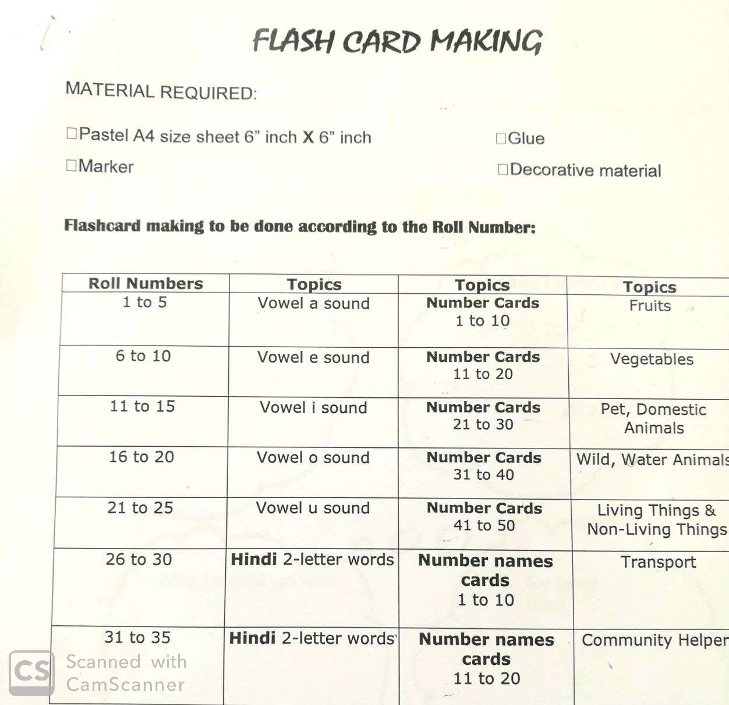

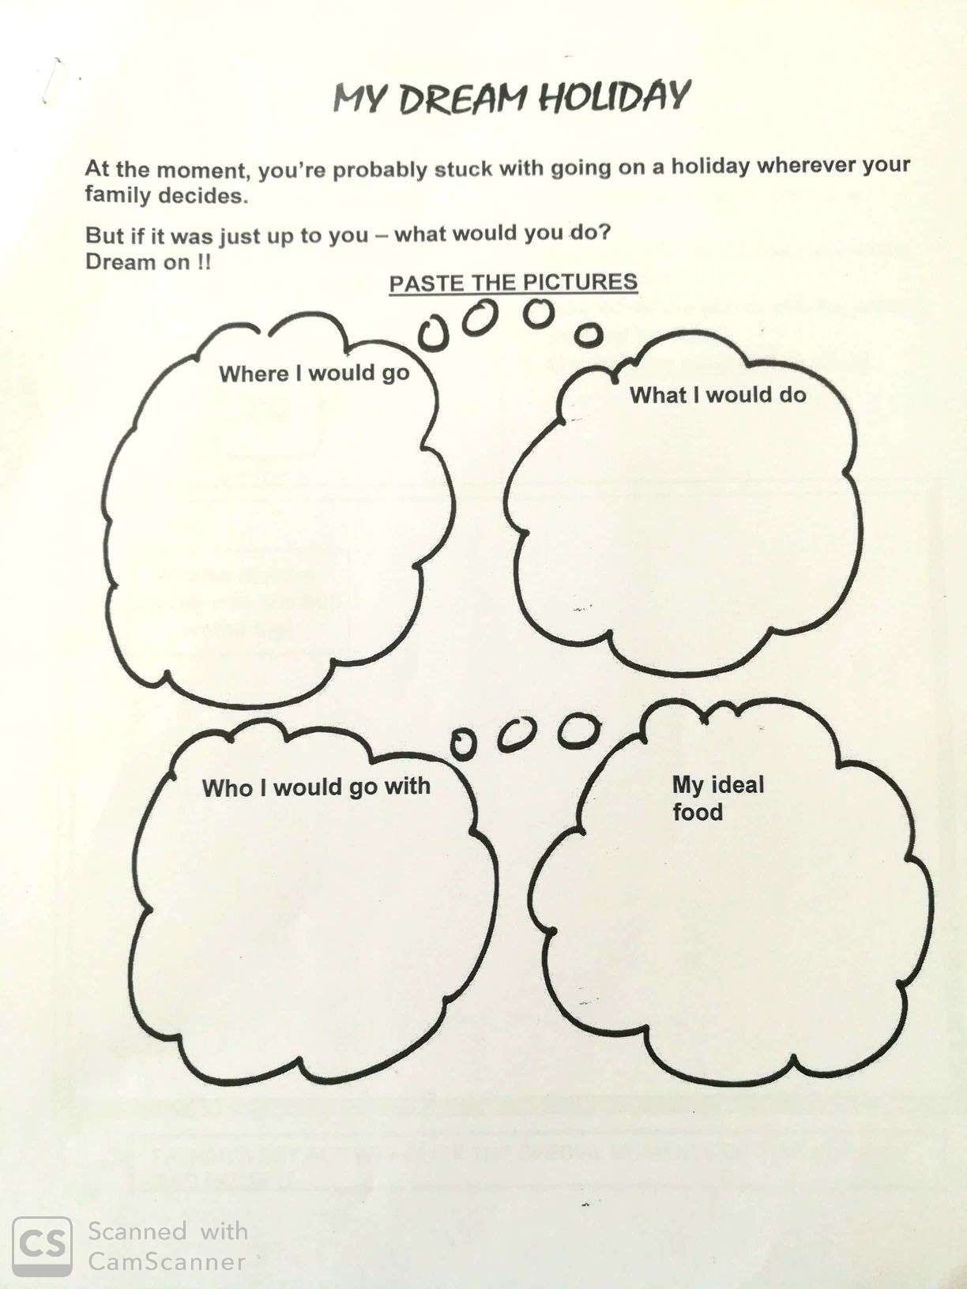

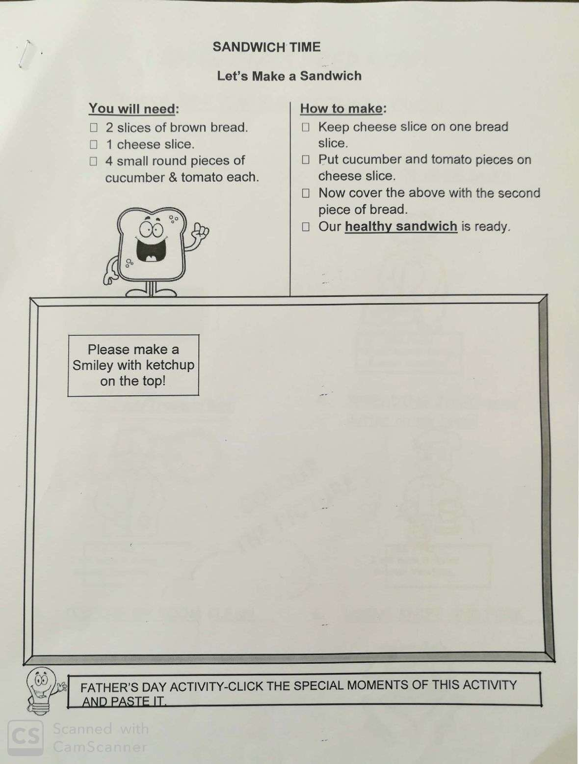

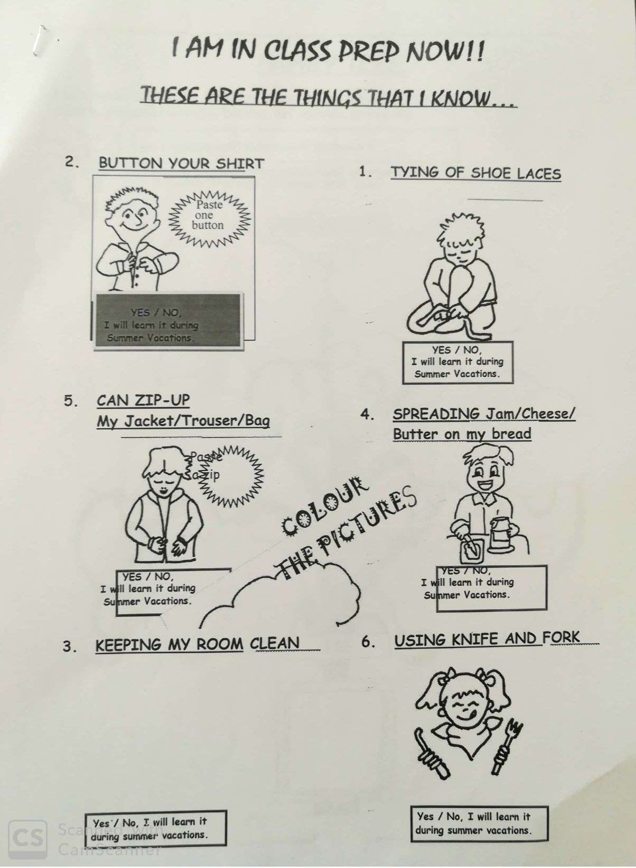

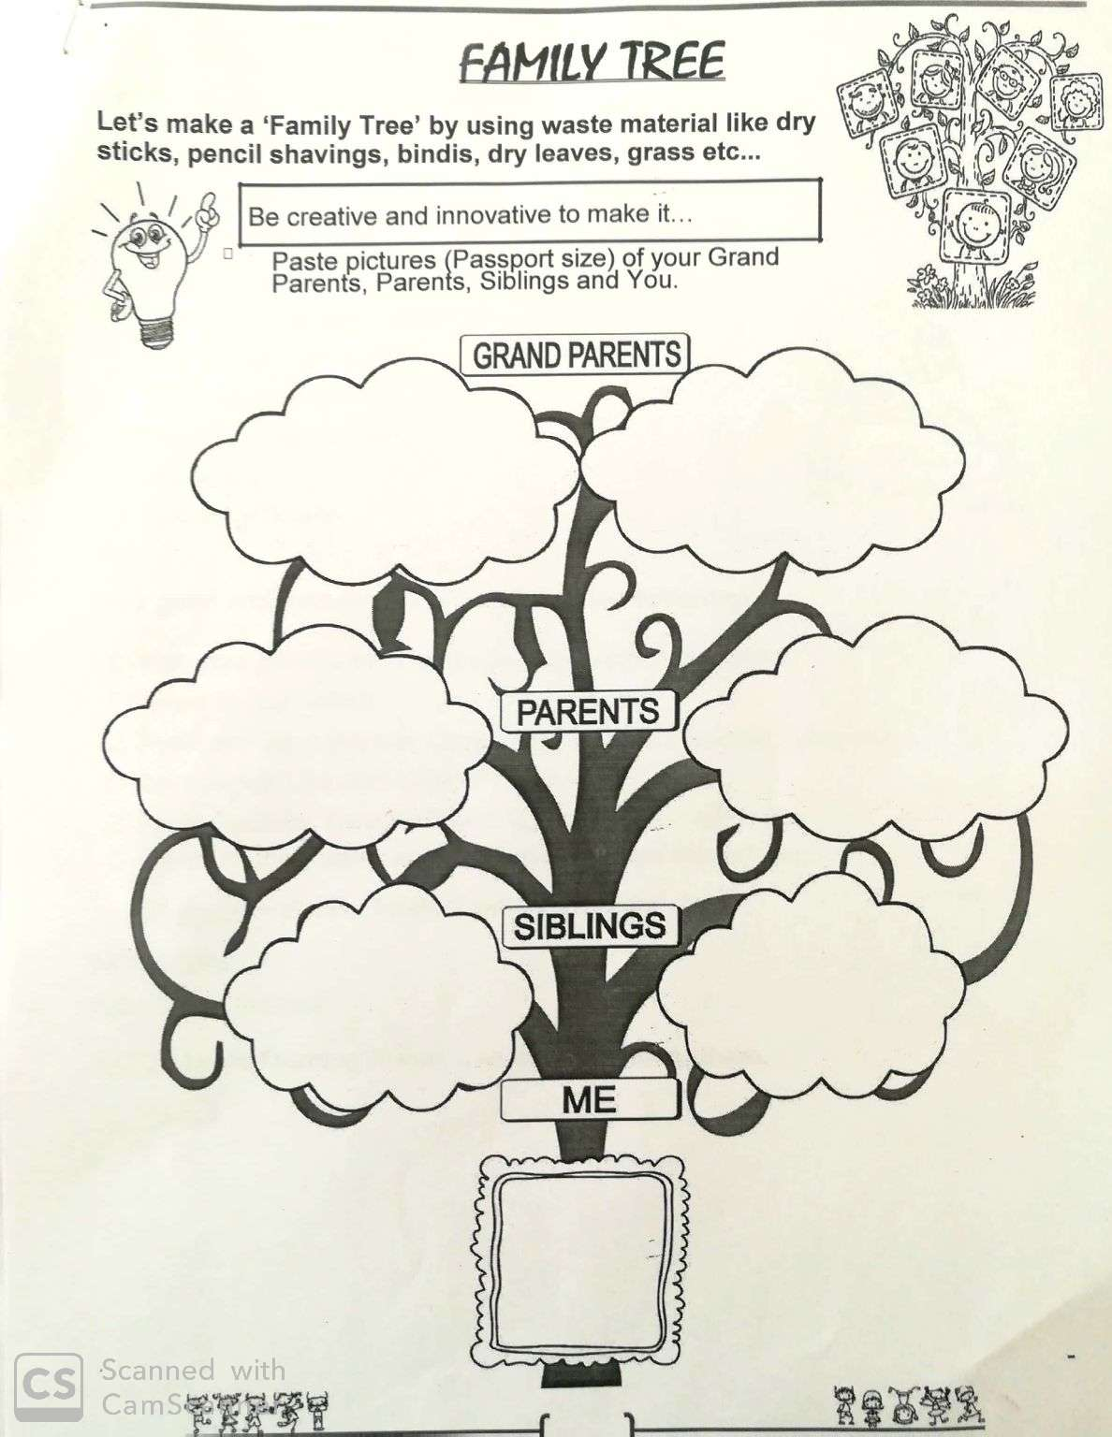

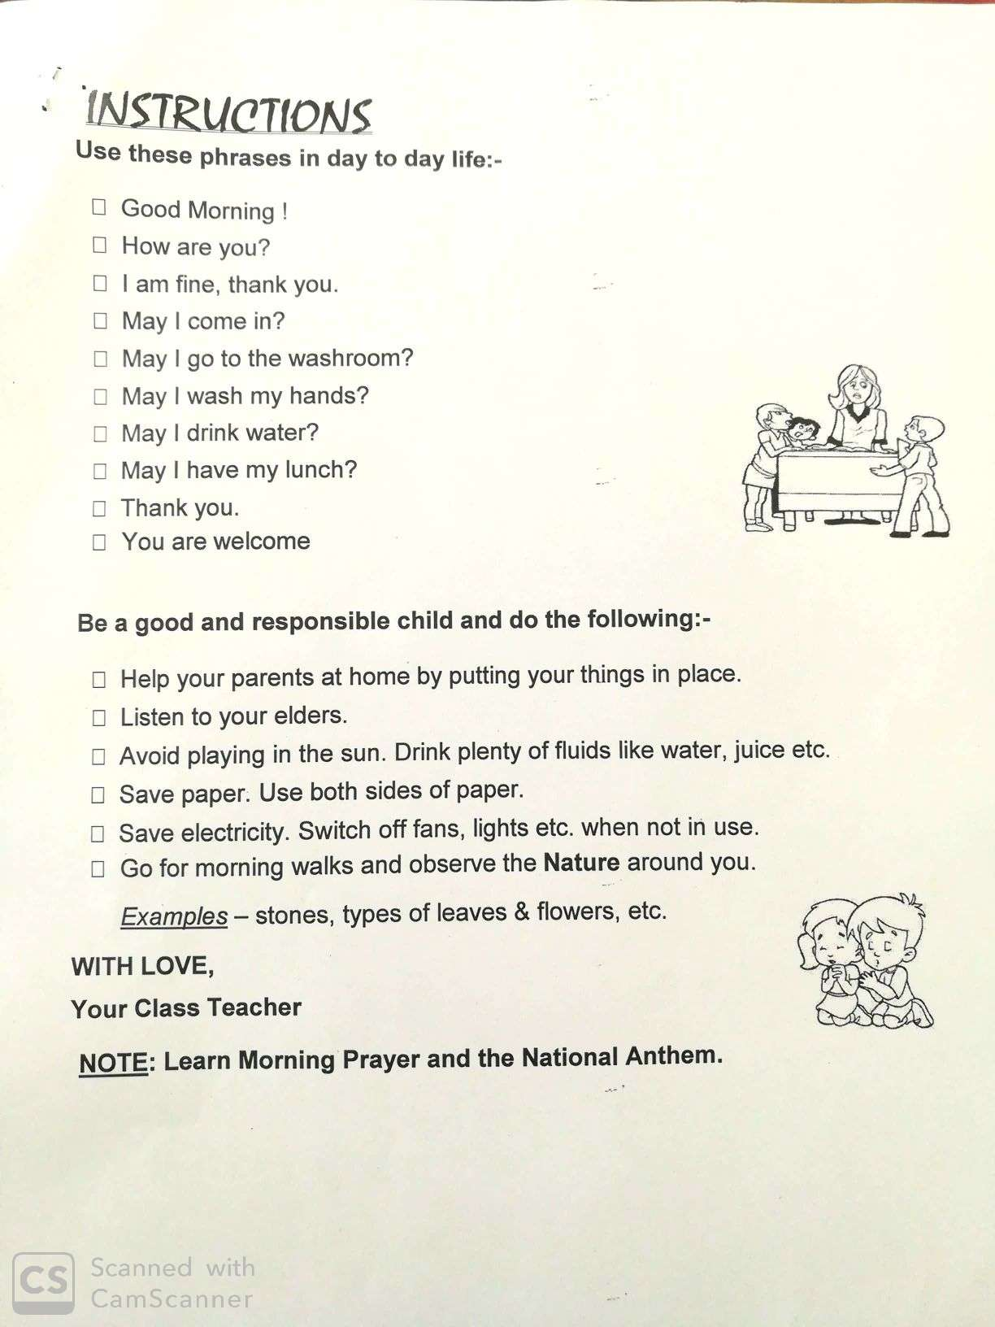
- Our Expectations from Parents
- Dear Parents,
- Our school management and teachers try to instil soft values in our students in their daily routine
- like caring and sharing , good relationships and mutual respect etc. We request all parents to reinforce such values in their wards during summer vacations and thereafter.
- So please take care of the following:
- 1. Parents are requested to spend some quality time with their children .
- 2. Get some good storybooks with colourful pictures for your ward and tell your child to read them
- regularly.
- 3. Let them sow some seeds / a plant and look after the plant regularly and watch them grow.
- 4. Let your ward spend minimum time in T.V , using mobile phones, internet and other electronic gadgets.
- 5. Encourage them to write two pages transcriptions daily to improve their handwriting .
- 6. Give stress on practicing one moral value daily.
- 7. Encourage your child to help you in small thingsrelated to Kitchen/Cleanliness.
- 8. Discourage your child to eat fast food like burger, pizza and carbonated drinks.
- 9. Allow your child to play outdoors games as it helps to make them strong.
- 10. Plan a holiday trip with your family for recreation.
- Wishing you Happy and fruitful holidays.

Principal

HAPPY HOLIDAYS

