M.R VIVEKANANDA MODEL SCHOOL, Sector – 13 Dwarka
HOLIDAY HOMEWORK
CLASS – NUR. (2019-20)
Dear parents,
The most awaited Summer Break is from 18^{h} May to 30th June. As per forecast by weather department the temperature will rise more and warm breeze (Loo) will blow. We suggest the following measures for your wardto remain healthy and hydrated:
- Wear cotton clothes, consume more liquids and water, go for morning walks. We want our students to utilize this time in a fruitful manner.
- Remain indoorfor most of the time, read newspapers, spend value time with elders and grandparents, help parents with daily chores, watch TV channels like National Geographic and Discovery.
Teachers have planned interesting, creative and knowledgeable home work.
Ensure that your ward does the Holiday Homework on his/her own using innovations. Guide and assist them only.

Principal

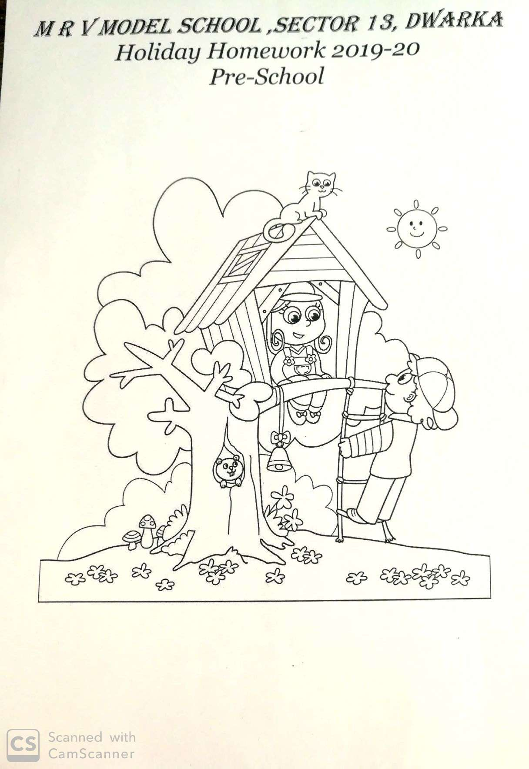
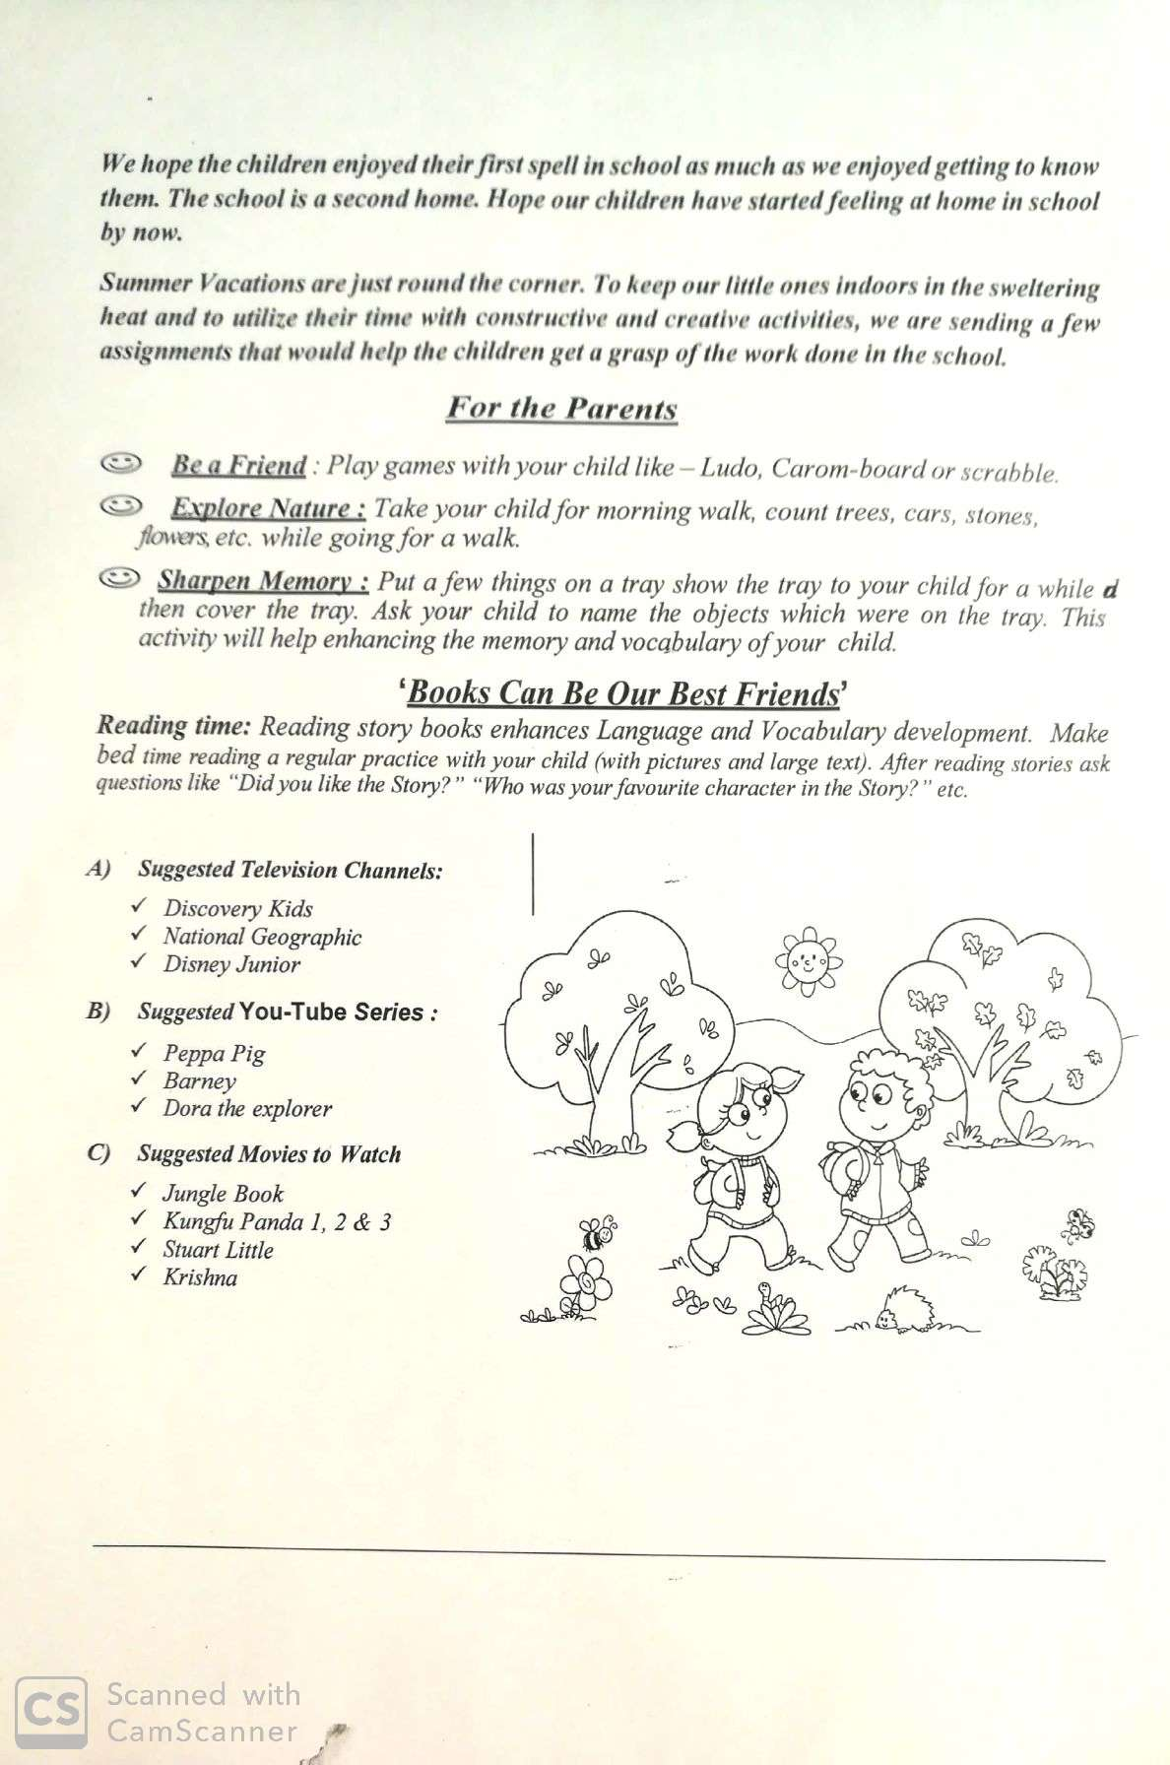
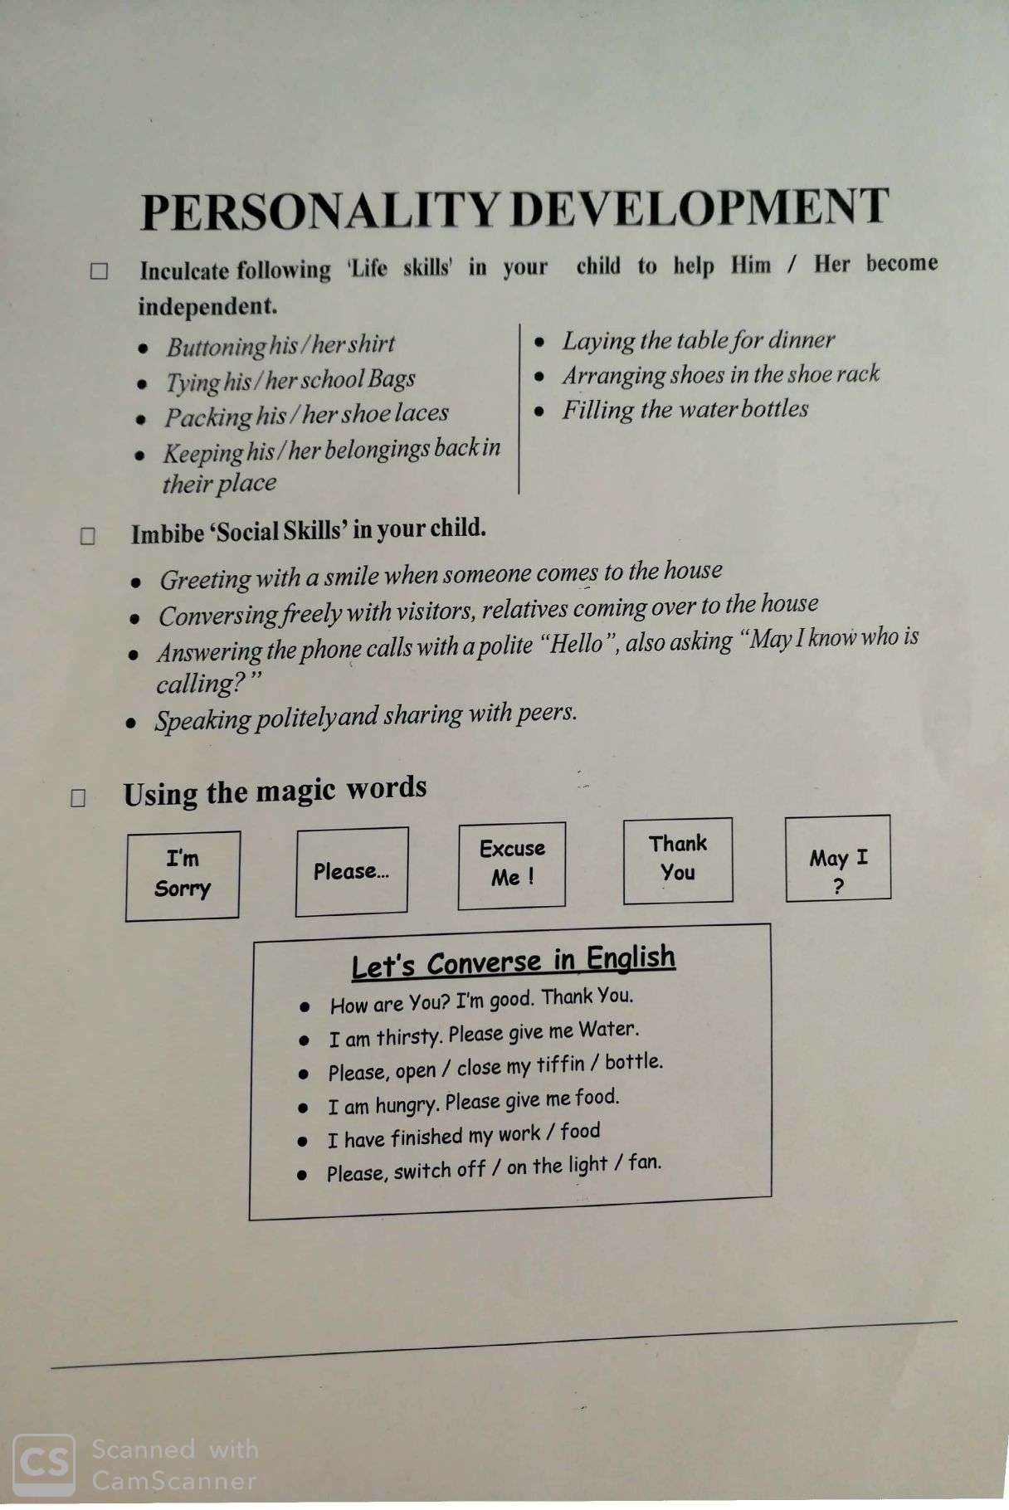
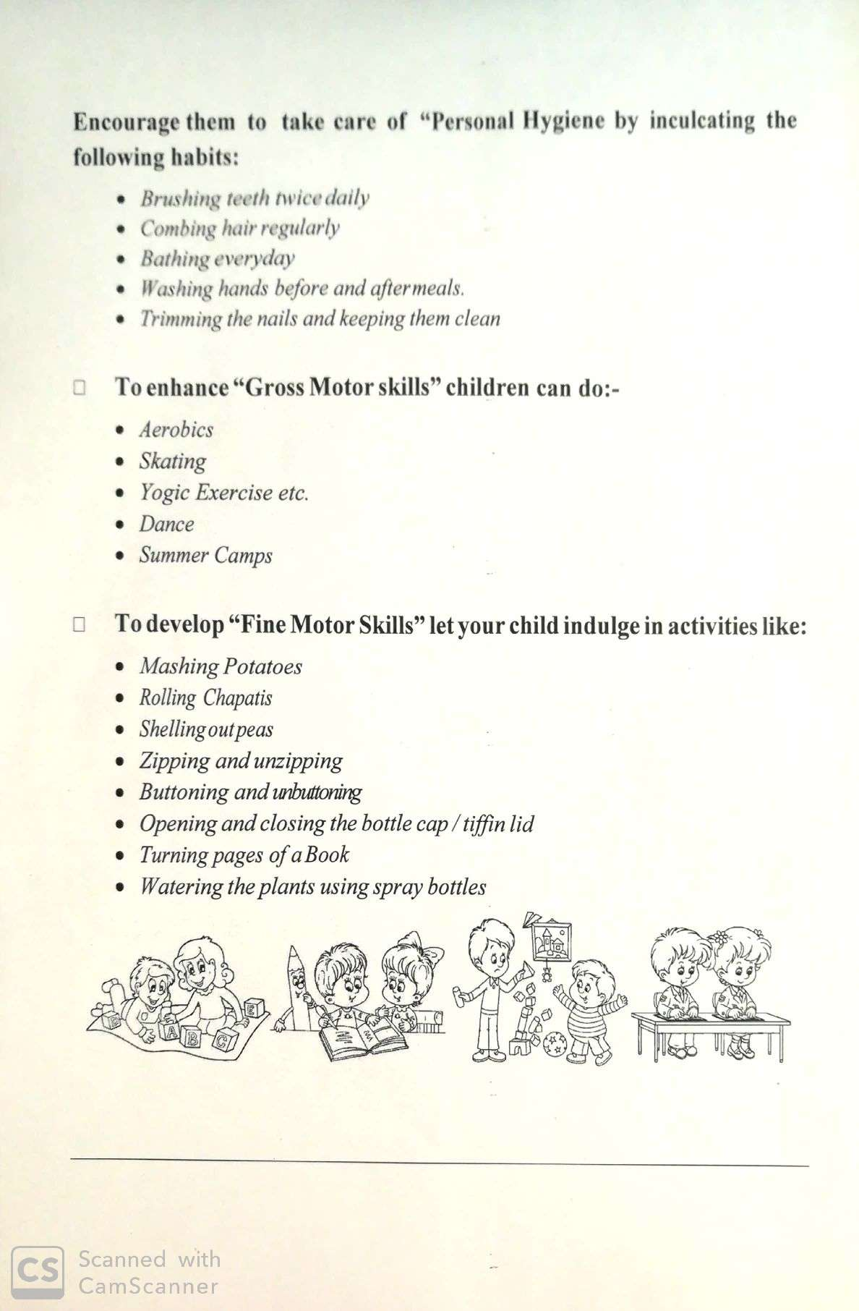
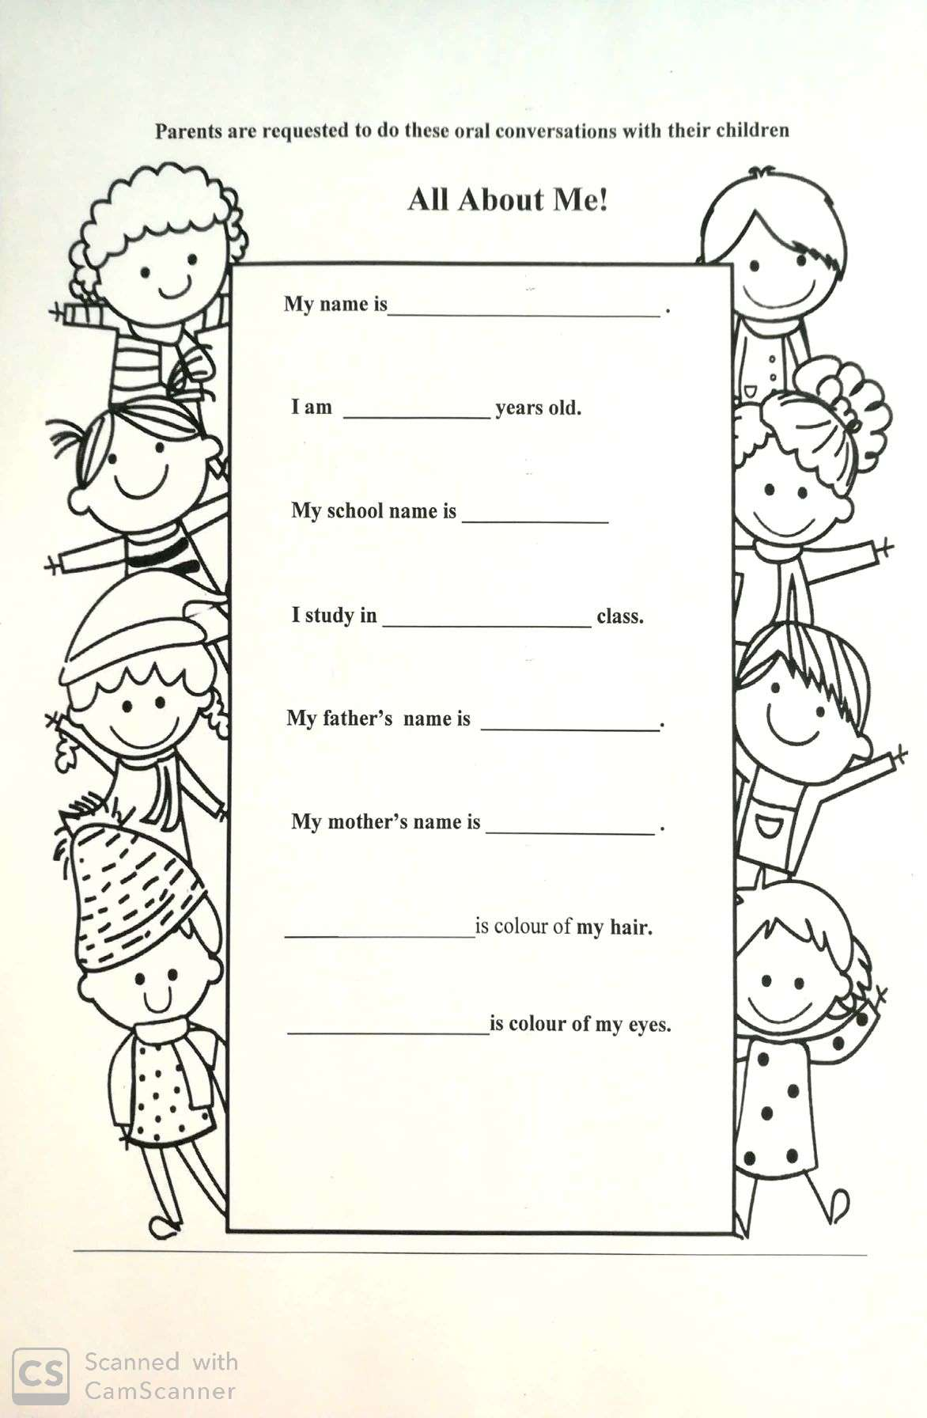
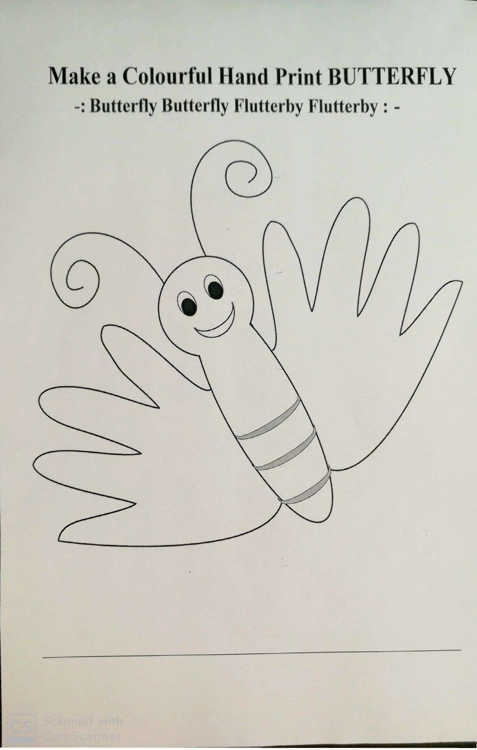
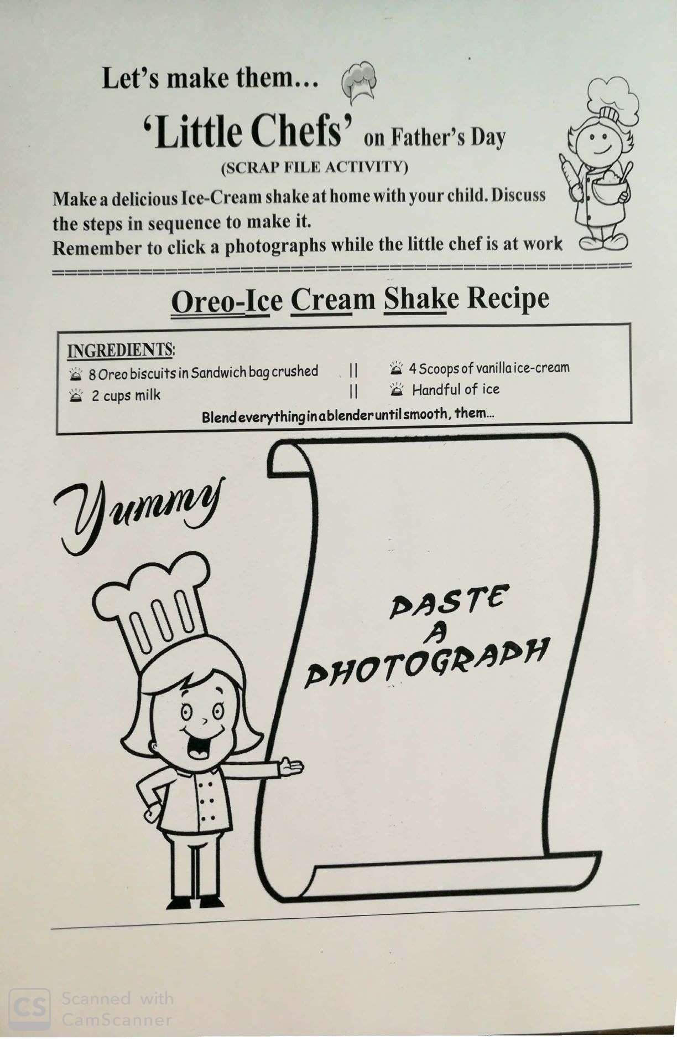
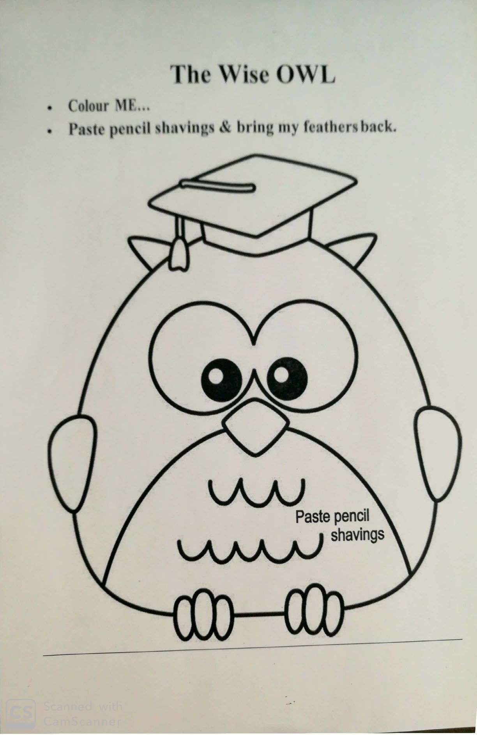
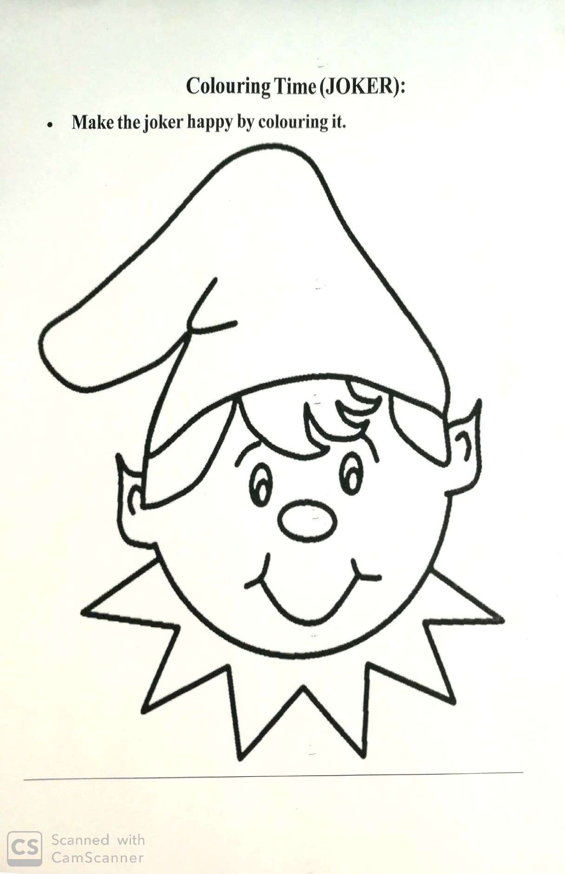
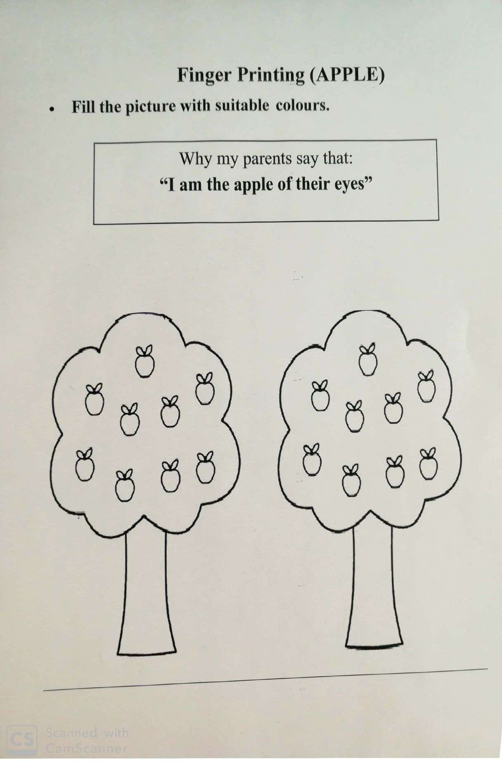
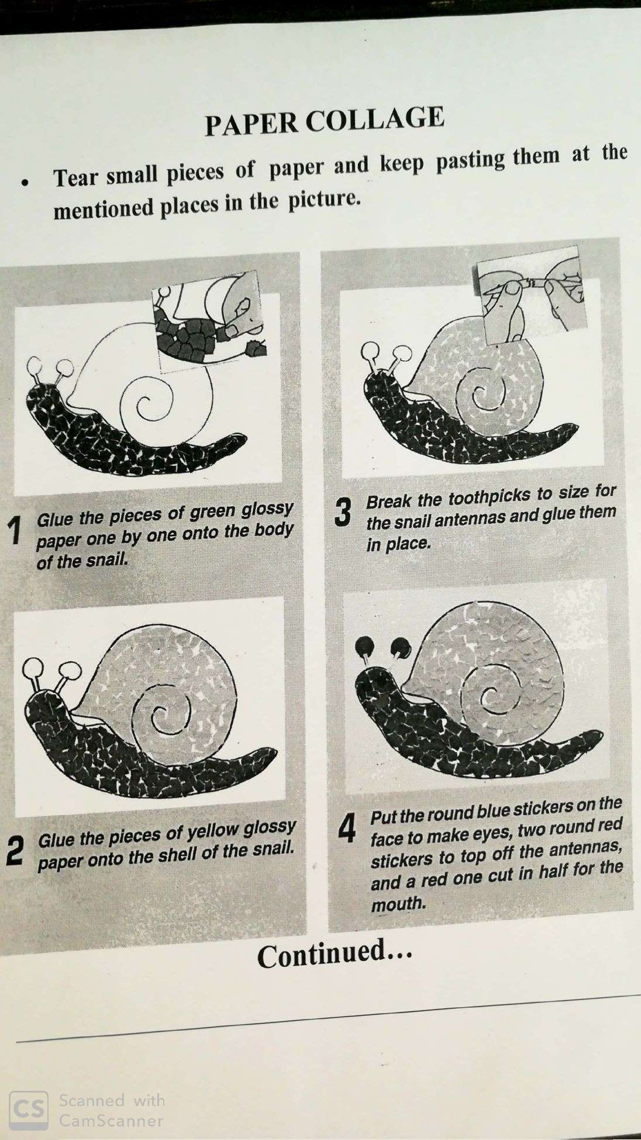
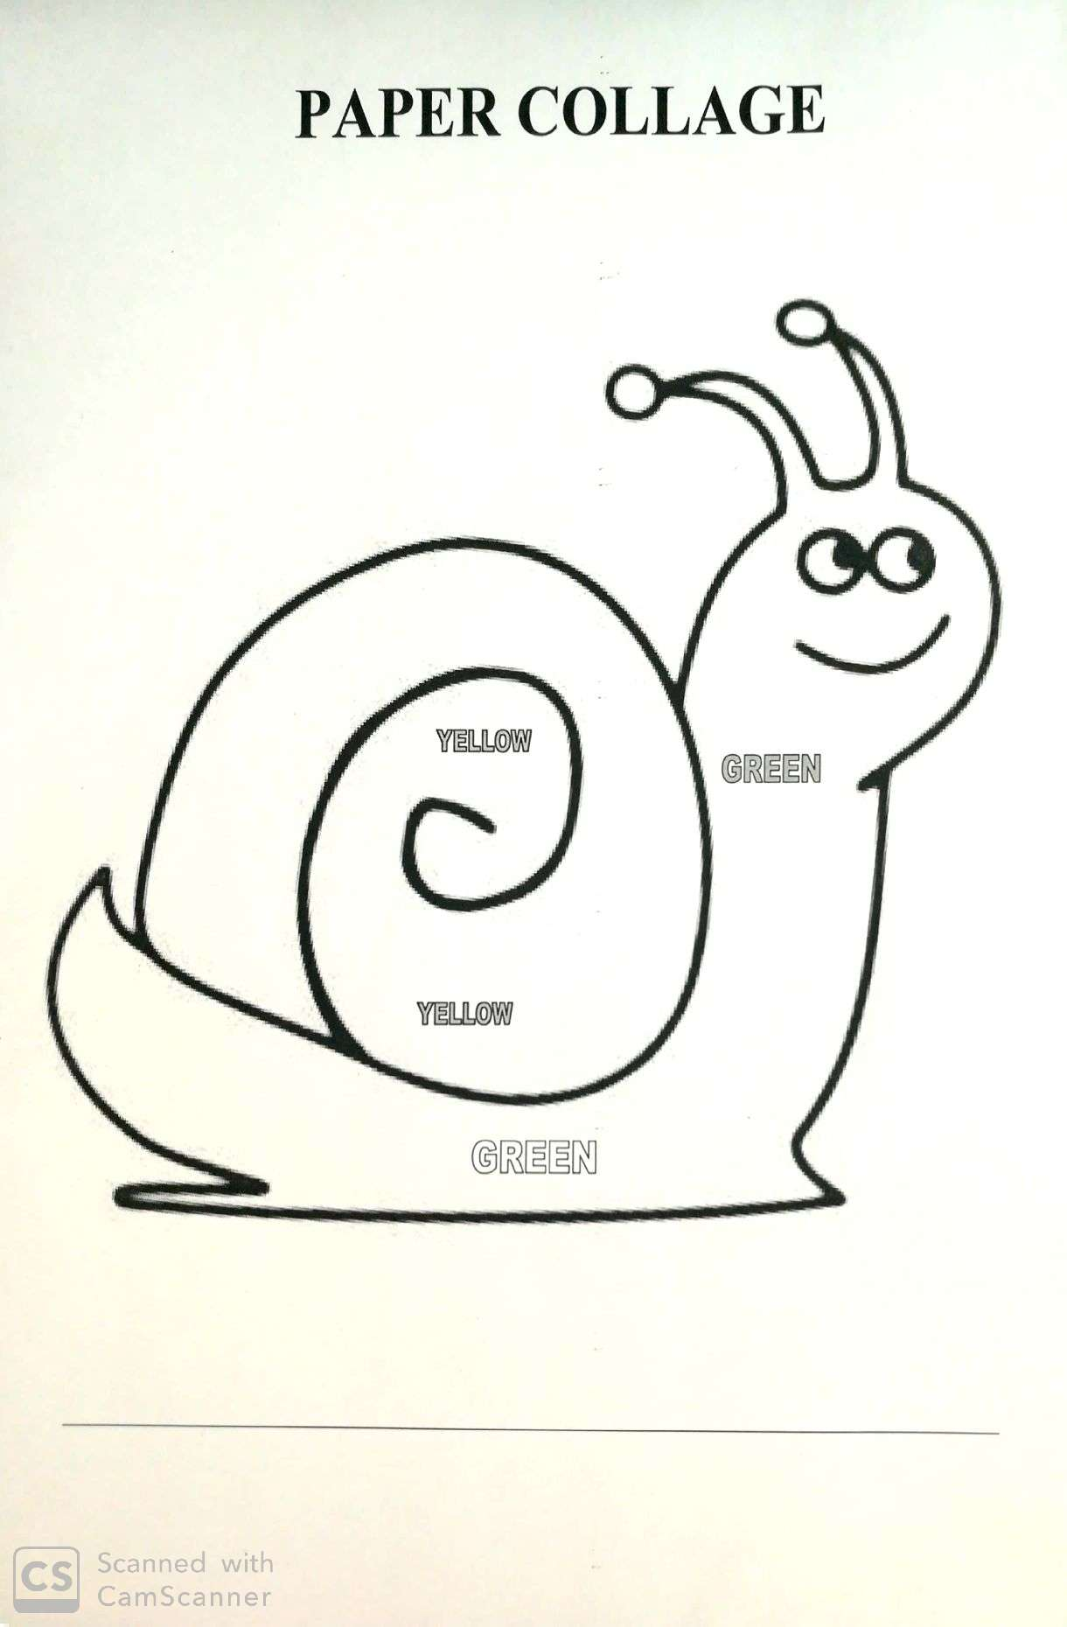
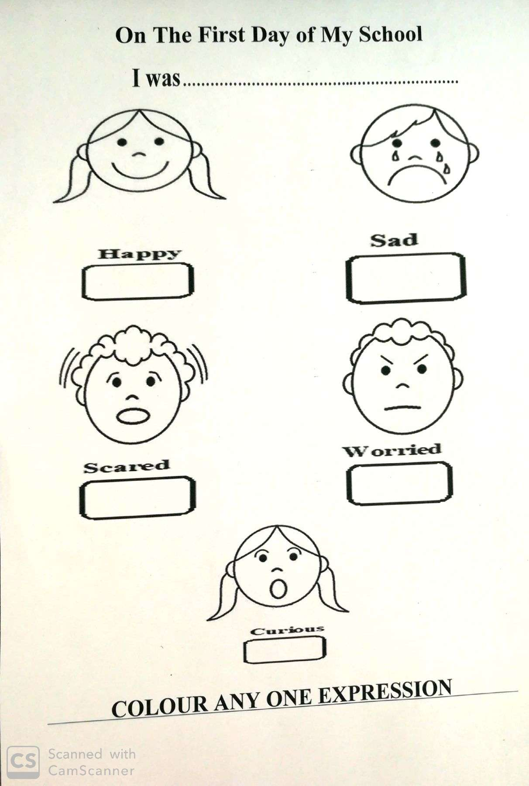
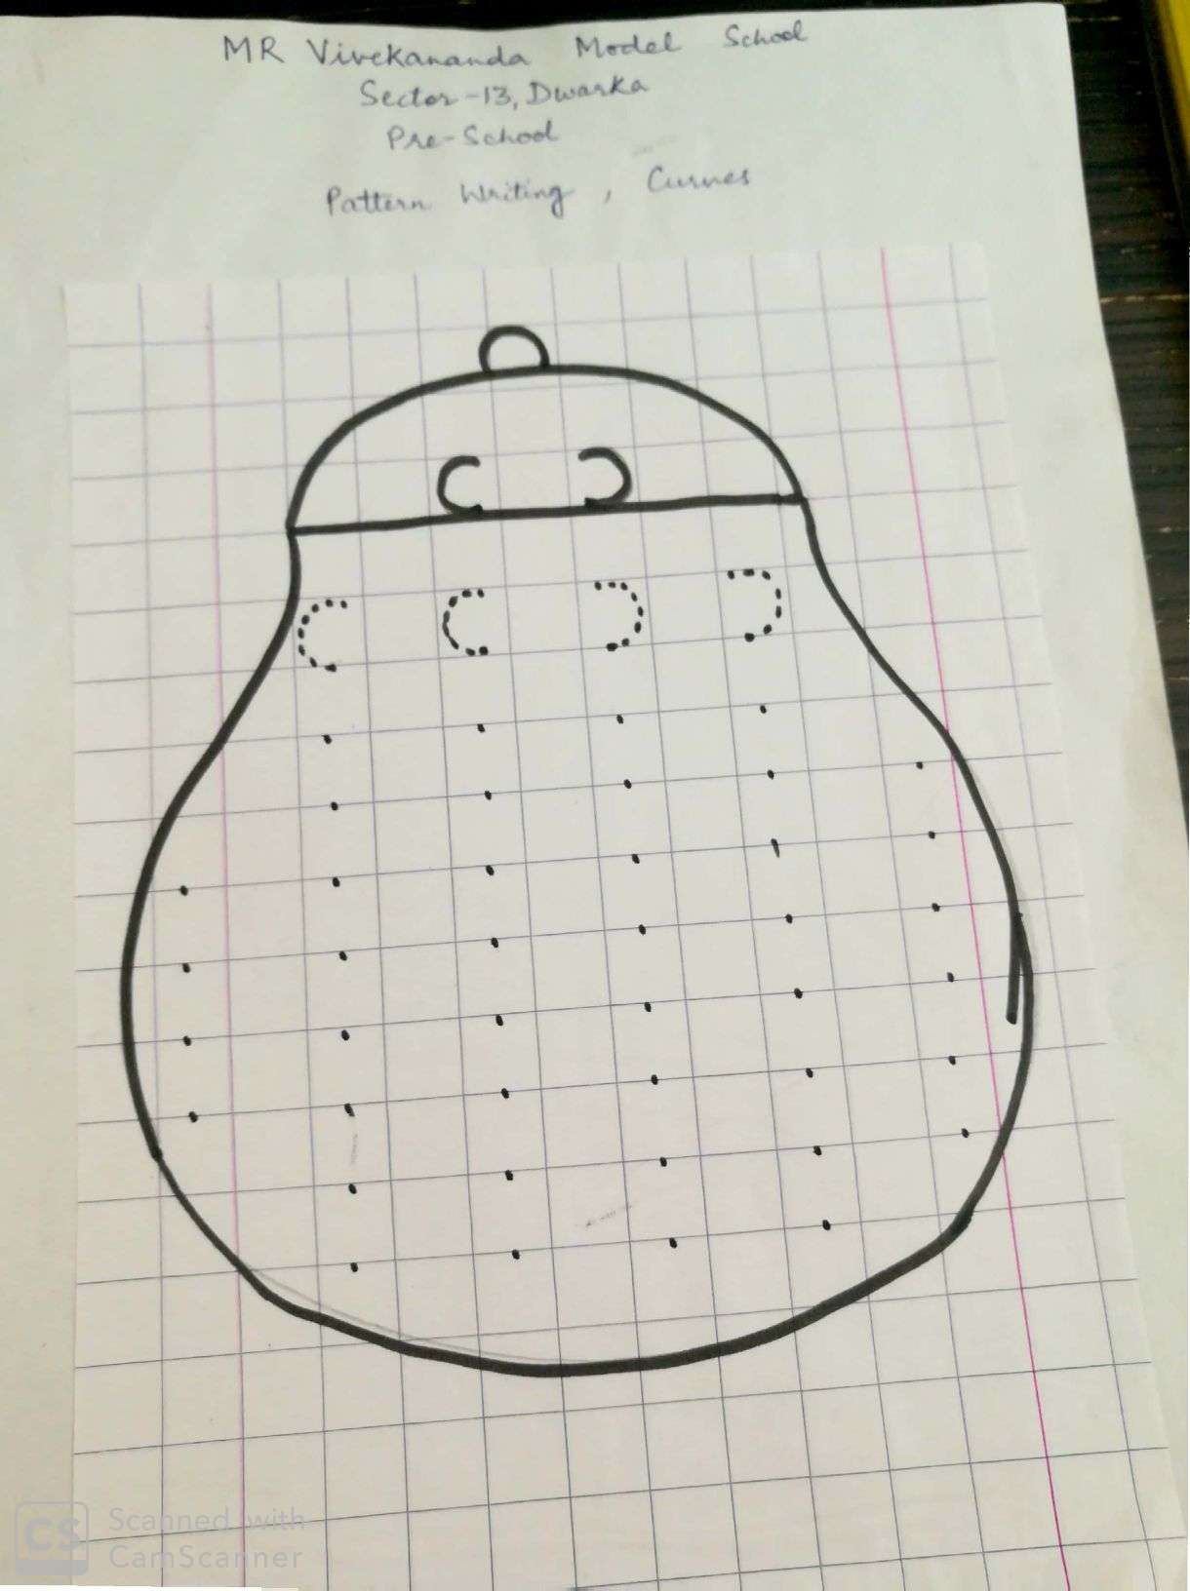

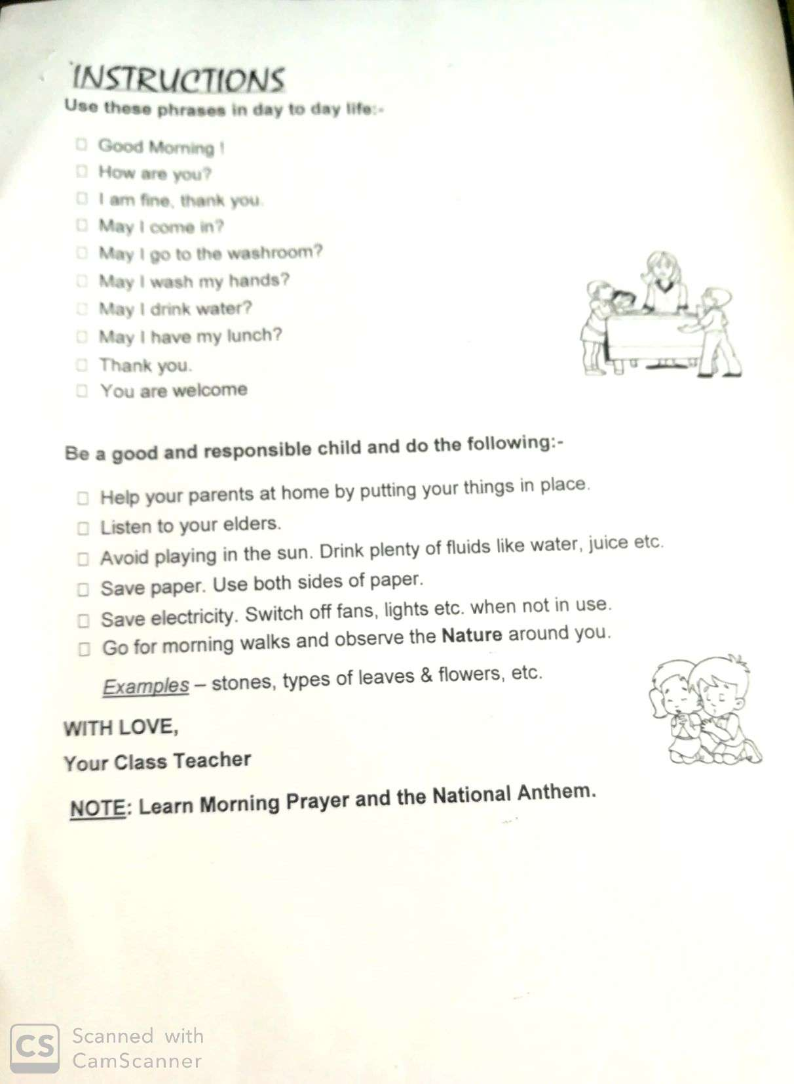
Our Expectations from Parents
- Dear Parents,
- Our school management and teachers try to instil soft values in our students in their daily routine
- like caring and sharing , good relationships and mutual respect etc. We request all parents to reinforce such values in their wards during summer vacations and thereafter.
- So please take care of the following:
- 1. Parents are requested to spend some quality time with their children .
- 2. Get some good storybooks with colourful pictures for your ward and tell your child to read them
- regularly.
- 3. Let them sow some seeds / a plant and look after the plant regularly and watch them grow.
- 4. Let your ward spend minimum time in T.V , using mobile phones, internet and other electronic gadgets.
- 5. Encourage them to write two pages transcriptions daily to improve their handwriting .
- 6. Give stress on practicing one moral value daily.
- 7. Encourage your child to help you in small thingsrelated to Kitchen/Cleanliness.
- 8. Discourage your child to eat fast food like burger, pizza and carbonated drinks.
- 9. Allow your child to play outdoors games as it helps to make them strong.
- 10. Plan a holiday trip with your family for recreation.
- Wishing you Happy and fruitful holidays.

Principal

HAPPY HOLIDAYS

